Lung Mechanics Procedures
Lung Preparation for Cavitation
John, Research 87, tel #: 1-774-245-0024
- When the lung is delivered, immediately put it onto an ice bath in a plastic tub and open the bag. This will allow for the blood to be absorbed and easily disposed of.
- Remove the “other” parts of the lung using a scalpel or other sharp implement, such as surgical scissors. Be aware that porcine lungs have two lobes on each lung (upper and lower) as well as a small side lobe. DO NOT CUT THESE OFF OR APART. The goal is to separate the two lungs and leave them intact so that you are aware of what part you are taking to test mechanically.
- After removing the other organs and scraps, place them into a trash bag or red plastic bag. Place the lungs into a new ice-filled container.
  - At this point, there should be no or minimal blood. Foam containers should be disposed of if used as they do retain blood and smells.
- Bring the lungs to Conte to perform the tests on ice in a covered container on ice as this will help to prevent the lung from becoming damaged due to the temperature as well as from drying out.
- Lay the lung on a cutting mat with grid lines. The mat should be covered with plastic wrap to contain fluids and prevent contamination of the mat. Gently wrap the lung with the plastic wrap, being careful to not significantly deform it.
  - Align the lung so that the large, flat portion of the lung (interior portion) is along one of these lines. The image below shows a properly wrapped lung. The inner portion of the lung is ALWAYS labeled with “A” and the bottom portion (larger segment of the lung) is ALWAYS labeled as 1.
  - After aligning the lung on the grid as seen below, draw the lines with a Fisherbrand marking pen.
- One lungs have been used and the testing area cleared of debris, clean the area and implements with 10% bleach and 70% Ethanol.
- Place all contaminated items into appropriate containers with regards to sharps.
- Lung material can be placed into a red biohazard bag or normal trash bag and frozen. Once sufficient amounts of material have been collected, waste disposal can be called for.
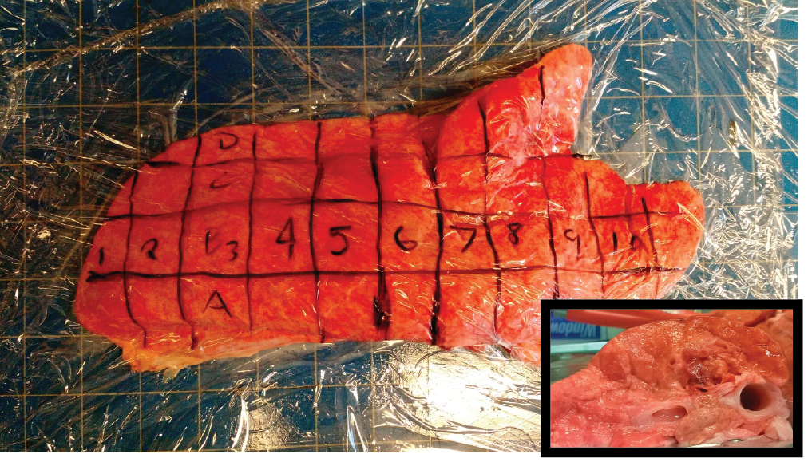
  - Contact EHS for appropriate biohazard waste removal. DO NOT allow the lungs to sit out in a bag as it will smell very bad after only a few hours. (jladuc@ehs.umass.edu)

Cavitation Procedure:
Please see a member of the Crosby Lab for Instructions on operation of the cavitation machine. This is a brief overview based on the cavitation of lung samples or samples that are large in area.
- Record the ambient pressure and temperature in the room based on external readings.
- Set up the instrument with a beveled or flat end needle (16G-26G in diameter).
  - For lungs, use the beveled needle as it is able to pierce the tissue to obtain pressures.
- Ensure that the syringe is pulled as far back as possible with the syringe rate set to 5000ul/min
  - Make sure the syringe is NOT in the tissue or other medium when filling it with air.
- Calibrate each sample using water.
  - Ensure that you get an appropriate surface tension value when calculating the cavitation pressure for water.
  - It is often helpful to have 2 people do this. One to watch the pressure and one to alert when the bubble emerges from the tip of the needle.
- Inject air into the tissue after piercing it. Make sure the needle does not go very far down into the tissue unless you desire this.
  - Make sure the needle enters the tissue on its own and do NOT push the needle or move it while it is in the tissue.
  - Start injection of air after about 5 sec of “baseline” data.
  - For the lung, make sure that you are not inflating the lung itself, nor are you deep into the cartilaginous region of the lung.
- Watch the LabVIEW program for any signs of cavitation or sloping of the data.
  - Once there is a sharp drop, halt the injection and the recording of the data.
- Remove the needle from the tissue and move to the next position. Continue until all available positions are finished and repeat with a new needle.
  - Loosen the needle after each run to ensure that there is no matter clogging the needle and therefore not returning it to ambient pressure.
  - If there is a pressure drop, clean the needle out with using a plastic syringe loaded with ethanol and / or water.
- Data analysis is handled as follows:
  - Use the 5 sec of “baseline” data to zero the data. Sometimes the external pressure is difficult to use.
  - Subtract the average baseline data from the peak after filtering the data with a Butterworth filter. A MATLAB script is set up to do this analysis and output the cavitation pressure into an excel document along with the time to cavitate.
  - Find the y-intercept of the data to obtain the Young’s modulus.
    - 1/r (x; r = needle radius) vs (cavitation pressure)

Shear Modulus
Shear modulus is tested on the rheometer in Conte on the 3rd floor using a range of testing parameters. Use the 20mm diameter plate along with the solvent trap to prevent the lung samples from drying. They are VERY sensitive to being left out in the open air as well as affected mildly by temperature variations. Please train on the equipment prior to using this protocol with a member of the corresponding lab (Schiffmann or Winter).
- To prepare the tissue, cut a square of tissue according to the grids drawn on the lung. The square of tissue is then sliced using a pair of surgical scissors to obtain a thin slice.
  - Take care to avoid cartilaginous regions and use the top or the bottom segment of the lung.
- Using a circular punch from the Schiffmann lab (7/8” in diameter), punch out the lung tissue circle using a hammer.
  - The lung sample is then placed into a 6 well plate with water in one of the wells / in the space between the wells to keep the samples hydrated.
- Place the tissue onto the flat bottom plate of the rheometer and trim to 2mm in height as necessary, ensuring the sample is flat and does not have pockets. Also, make sure the edge is trimmed to the exact diameter of the upper plate.
- Make sure that the plate is completely in contact with the sample and has a small force (<1N).
- Using a strain of 0.5%, test the samples from 0.1 to 1Hz using the rheometer. Use the 0.1Hz result as the shear modulus.
  - Remove the results that do not have a “smooth”, logarithmic growth curve that’s increasing over time in modulus. It is likely that there was an error in preparation or equipment set up.
  - If there is “slippage” in the first point, add a measurement point prior to 0.1Hz. Sometimes the instrument has issues with equilibration. Try to decrease the normal force on the sample.

Uniaxial Testing Using Instron
Please obtain training from a member of the Crosby lab prior to performing ANY measurements with the Instron.
- Make sure to set up the Instron appropriately. See Instron Procedure.
- Cut the lung into squares according to the grid. Do this ONE AT A TIME.
- Cut the lung square into strips up into 2.75-3cm x 1cm long strips with a thickness of 2-4mm.
  - Surgical scissors are invaluable at doing this. It’s very difficult to “slice” the samples otherwise. You need to trim them and “shave” down the surface without straining the sample.
- Measure the thickness and width of the strip prior to hanging.
- Hang the lung strips in the grips and make sure the strip is hanging vertically before closing the grips.
  - Set the pressure to 50 PSI to make sure the sample isn’t completely destroyed.
- Close the upper grips down onto the sample, making sure the sample is not completely crushed, but held very firmly in the grips.
- Zero the balance and lower the lung sample into the lower grips.
- Close the lower grips and increase the distance until there is a very small force on the sample (<0.01N).
- Zero the distance to set this as the initial displacement.
- Measure the distance between the grips to obtain the initial length of the sample.
- Set the strain rate to 1% of this in mm/sec for lung tissue.
- Strain until you see a sharp or ragged slope appear or fractures in the sample.
- Stop the test and remove the sample.
- Send the data to a Crosby lab member to obtain the actual results since the output of the machine is often incorrect and because there may be more informative calculations.
- Calculate the slope of the initial region to obtain the modulus.
  - For lung and many biological tissues, the slope of the “toe” region is more appropriate to the tissue properties while the rigid “sloped” region is more the properties of collagen / connective tissue.

Instron Procedure
Please receive training from a member of the Crosby lab prior to using the Instron. This is a mostly detailed procedure guide for someone who has been trained in a basic manner on the instrument.
- Turn on the Instron using a switch in the front, left of the machine.
- Ensure that the numbers on the Instron count down to 1 prior to making any adjustments.
- Lower the Instron until you can see the top of the load cell. Check that the load cell is the appropriate size for the application.
  - Use a 50N load cell for lung / most tissue samples.
- Replace the Load Cell if necessary.
  - Turn off the Instron after lowering it to the appropriate height once identifying that you want to replace the load cell.
  - Loosen the screws on the load cell with the Allen wrenches provided.
  - Remove the COM cable before removing the load cell.
  - Place the old load cell into the foam box container, making sure not to hit or tap the cell.
  - Insert the new load cell from the foam box container into the Instron.
  - Make sure that you can read the words from the “right side up” when you stand by the computer.
  - Use the torque wrench to tighten to the appropriate tension. It should be appropriately set.
  - Attach the COM cable back to the new load cell.
  - Turn on the Instron again and make sure the machine counts down to 1.
- Open the BlueHills program and calibrate the load cell without any grips or devices attached to the load cell.
  - Once calibrated, hang a brass weight to the load cell directly and ensure it is the correct amount of force.
- Adjust the frame until you can insert the grips comfortably into the positions without having to contact or touch one another.
- Attach the large bottom grips to the base of the Instron and insert the appropriate pin.
- Attach the top grips using the small adapter along with the pins and clips. Make sure the top and bottom grips are aligned to hold the sample in a straight, up and down fashion without twisting.
- Tighten the upper grip in position using the collet.
- Set the yellow stop on the frame to approximately slightly smaller than the smallest expected sample so the arm does not crash into the lower grips.
- Attach the pressure hoses to the grips and set to 50PSI.
- For each sample, the procedure is:
  - Raise the frame so that the bottom of the sample does not touch the bottom grip.
  - Measure the width and thickness of the sample and enter it into the software.
  - Clamp the sample in the grips using the pressure switch and make sure the sample is vertically aligned.
  - Balance the load to 0N to compensate for the weight of the sample.
  - Lower the frame until the sample is in the lower grips a good distance (approximately 0.5cm).
  - Close the lower grips using the pressure switch.
  - Increment the distance slightly until there the tension increases to remove the “slack” in the sample.
  - Zero the displacement of the grips.
  - Measure the distance between the grips using calipers to get the length of the sample.
  - Stretch the sample as desired.
    - For lung, set the strain rate to 1% / sec in mm/sec.
    - Remove the sample and repeat.
  - Hit “Finish” after completing the desired number of runs.
    - “Save” or “Save As” DOES NOT SAVE YOUR DATA!!!!

Micro-indentation
- Calibrate the instrument using training protocols.
  - Use the Crosby lab calibration protocol for the cantilever and set up the instrument using the desired flat punch. 1mm diameter is appropriate for lung tissue with the #2 thickness cantilever. Softer samples (<1kPa) will require a smaller punch and / or thinner cantilever.
  - Make sure the punch is aligned well and flat using a piece of flat PDMS adhered to glass by putting the punch into contact while observing using the microscope. It should contact the glass simultaneously in all areas of the punch at once.
  - Place weights on to the cantilever ranging from 10-500mg and record the weights on the LabVIEW calibration program. Calculate the relevant slope of mass vs. deflection to get the spring constant of the cantilever.
    - If the calibration is off (R² < 0.95), you may have to readjust the cantilever or re-ground the electronics.
  - Open the measurement LabVIEW program and enter the spring constant of the cantilever as calculated.
  - Perform an indentation test on a flat piece of glass, which is used as the testing platform. This will give use a baseline for the sample. Use this platform for each test. You need to calibrate for the surface modulus each time you change the platform.
  - Make sure to record the initial position and make sure that the initial position is “0”, but it doesn’t have to be. This makes it easiest.
- Cut the lung into squares according to the grid as seen before. Do this ONE AT A TIME.
- Cut the viscera pleura away from the tissue. The surface WILL dry over time.
- The tissue is then placed into a 6 well plate with water in one of the wells to keep the samples hydrated. Samples can be quite thick.
  - Thicker samples are better as the measured thickness of the samples will have less of an effect on very thick samples.
- Immediately before testing, cut the sample in half.
  - This allows testing of the hydrated portion of the samples.
- Record the starting position of the micro-indenter.
- Indent into the tissue at the desired rate to the desired indentation depth / force.
  - For lung tissue, use 20mm/min or slower to a force of 2mN.
- Repeat measurements 3x per sample.
- Calculate the modulus using the approved protocol.
  - Use MATLAB to calculate the slope of the samples
    - Calculate 1/slope of the calibration curve to calculate the compliance of the cantilever and underlying substrate.
    - Calculate 1/slope to get the compliance of the sample.
  - Use the equation:
$E= \frac{3}{8C(1+1.33\left(\frac{a}{h}\right)+1.33{\left(\frac{a}{h}\right)}^{3})a}$
$E=$the Young’s Modulus
$C$= Sample compliance – Surface & Cantilever compliance
$h=$height of the sample
$a=$radius of the probe

