1.
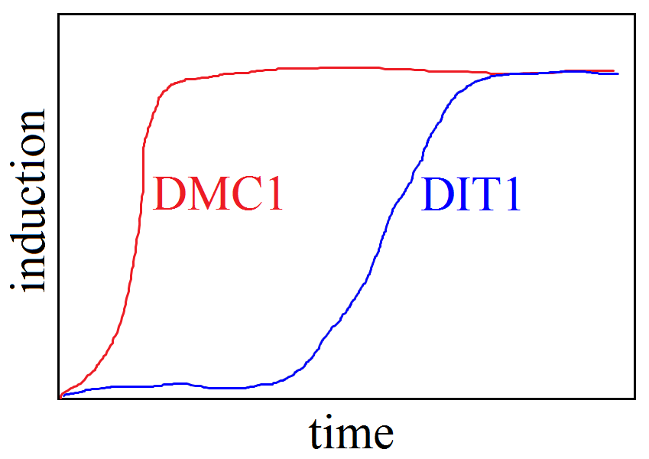
2.
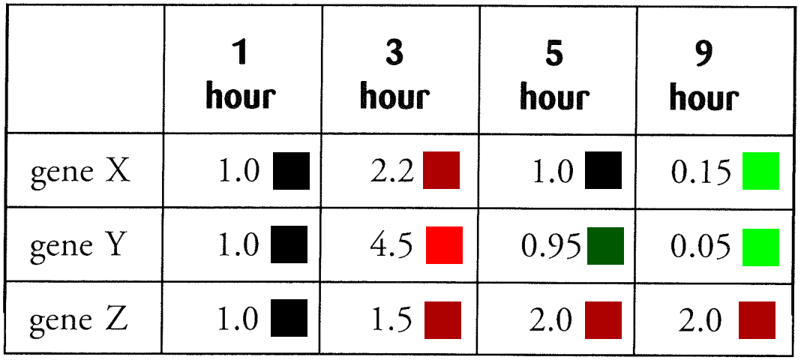

3.
No.

4.
It’s a combination of the colors green and red. The genes haven’t had enough time to become induced or repressed.
5.
Induced. It had to translate RNA that activates genes that respond to starvation.

6.
The yeast cells respond to glucose reduction by inducing and repressing genes in entire pathways. They probably want to focus on energy production instead of protein synthesis when their fuel is running low.

7.
Have them be induced or repressed by the same transcription factor.

8.
Red.

9.
Black.

10.
Check the colors of their respective spots. TUP1 should be green and YAP1P should be red.

