MAKE SURE YOU ARE LOGGED IN

- Go to this page
  - http://openwetware.org/wiki/Biology_210_at_AU:Lab_Members/Section_4_%282015%29
- On the left hand side, there is this menu.
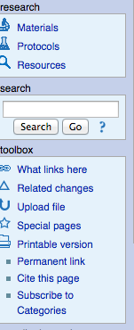

- Click on the upload file link. You must upload your image to the server before you upload it to your notebook.
- It will bring you to this page (see pic below). Upload your file from your computer to the server by clicking “choose file”.
  - In the “destination file box” make sure you name this something unique. “Alyssa_Pedersen_lab 1_transect overview.png” would be a good name. This name still needs to end in picture file format, so don’t forget to include “.png” or “.jpeg”
  - Write down what you named your file. You will need this later.
  - Now click button at bottom “upload file”
  - Your picture is now uploaded to the server.

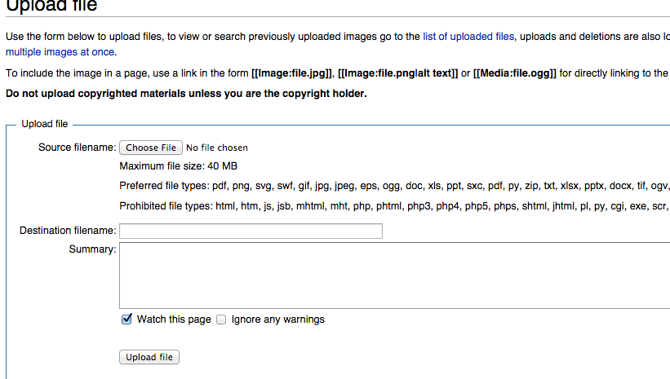

- Go back to this link:
  - http://openwetware.org/wiki/Biology_210_at_AU:Lab_Members/Section_4_%282015%29

- click on “(Your name) notebook”

- Click on the “edit” tab on the top of the page
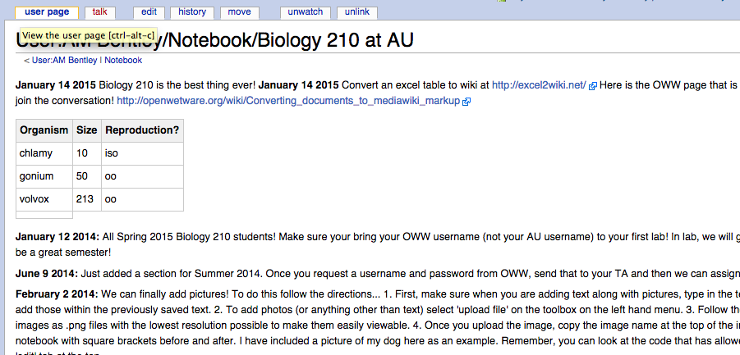

8. Click on the “picture icon” (see pic below)
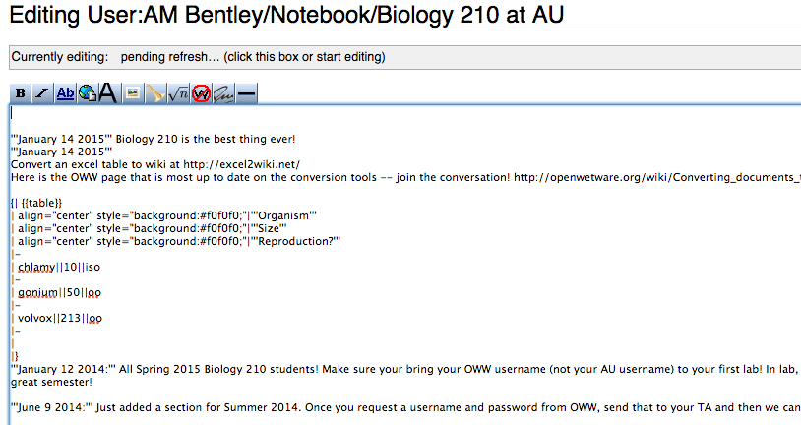

- When you click on that button, text will appear (see below). Delete the “image: example” and insert your own picture file name. For example, one file would look like this.
    - Make sure you have [[ ]] around the file name and that it ends in a picture format!
  - [[Alyssa Pedersen Transect1.jpg]]

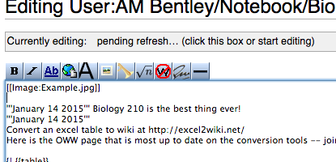

- Go down to bottom of the page and click save!
- Picture should appear!

Tips:
- If you have forgotten the name of your file, go here:
  - http://openwetware.org/wiki/Special:ImageList
- Try not to upload huge picture files into OWW. The way that I do this is to save the image of the wanted size to my desktop, and that would upload to server.

