**SEED Academy, Spring 2009**

**Synthetic Biology Module**

*Homework #3*

*Due March 7, 2009*

1. **Laboratory Project Overview**

The following schematic (adapted from MIT’s 20.109 DNA Engineering Module: <http://openwetware.org/wiki/20.109(F08):Module_1>) outlines the main laboratory project for this course. Study this schematic and answer the questions that follow.

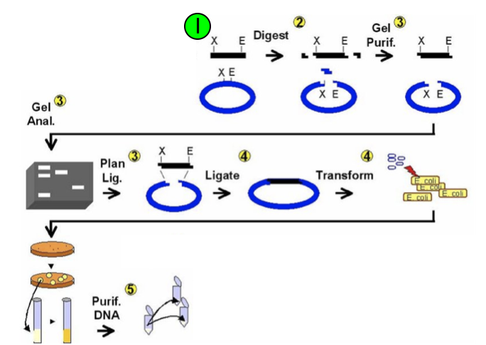

1. Which steps in the process have you already performed? Refer to the process name(s) that appear(s) above the arrow (e.g. “Digest”, “Ligate”, etc.) rather than the number(s). **Give a brief summary of the process(es).**
2. There are actually two slight discrepancies between what is shown in the figure and what you actually did in lab. First, so far you have only worked with one of the DNA molecules shown above. Which one, the “black” or “blue” one? What is the name of this piece of DNA? What is it and why is it important for your project? You can go to the project overview page (<http://openwetware.org/wiki/SEED/2009/Overview>) for help with this question. What is the second discrepancy?
3. **Restriction Digestion Revisited**

Examine the circular plasmid drawn below and answer the following questions. The numbers correspond to the location of the basepairs where restriction enzymes cut the DNA.

Plasmid Length (with insert) = 5000 bp

EcoRI (100)

XbaI (200)

SpeI (800)

PstI (1000)

XbaI (2000)

* 1. How many DNA fragments will result from digesting with the indicated enzyme(s)? What will the size of the fragment(s) be?
     1. EcoRI ____________
     2. XbaI ____________
     3. SpeI ____________
     4. PstI ____________
     5. EcoRI & SpeI ____________
     6. XbaI & PstI ____________

vii. EcoRI, XbaI, SpeI, & PstI ____________

1. **More on your Final Project**

At this point we have had a good bit of discussion about the “abstraction hierarchy” in synthetic biology, particularly focusing on *devices*. Now it’s time to think about your project in terms of the abstraction hierarchy. Last week we asked you to think about *how* your system would work. The natural question that ensues is this: What devices are necessary to achieve those functions? As you can tell, you should begin to keep a copy of your work on this question to go into your final project! For the 2-3 ideas you considered in more depth last week, complete the following tasks:

* 1. *Device List*. Very simple: list (or, if easier, describe) the devices your system would need in order to function. Try to think of at least two devices for each system (hint: the easier it is to think about these devices, the more likely it is that your system is plausible). For example, with the bacterial photography system, two devices would be a 1. Light sensor and 2. Color-changer.
  2. *Background Physiology about the Source and Target Strains of Interest* We want you to start to think more deeply about the organism in which you would like to work. What would be the capabilities of your “perfect” organism? Can withstand boiling temperatures? Can grow without oxygen? This could include things like where and in what conditions the organisms that have the desired capabilities live, what their nutritional requirements are, etc. The idea is that you think about and determine the organism that is best suited for your needs!
  3. *Real World Biological Interactions with System Interfaces*. From (a) you have a device list. Look into the biological background surrounding these issues (hint: as a first pass, Google and Wikipedia are your BFFs). For example, with the bacterial photography system, you would try to find biological components that respond to light and biological components that can be associated with color change.

**Resources:** Google and other search engines, the library (yes, the dreaded library can be good for some things!), Molecular Biology Textbooks, **TAs, and Instructors!**

*We will try to get you some personal feedback in the next couple weeks about your project, but if you have some questions you shouldn’t hesitate to email us!*