SEED Academy

Spring 2011

Synthetic Biology

Midterm Quiz

Name: Date:

You thought that the 2006 MIT iGEM project was kinda cool, but you have one small problem with it: you hate bananas! You love flowers, however. Jasmines, in particular. In the following problems, you will go through the steps of creating a strain of *E. coli* that smells like jasmine!

With a little research, you find out that *E. coli* naturally produces a compound called *jasmonic acid*. Because you are so good at research, you also find out that one of the popular model systems in biology, the plant *Arabidopsis thaliana*, contains a gene that converts jasmonic acid to the compound *methyl jasmonate*. We will call this gene *JAMT*.[1] Methyl jasmonate is the compound that smells like jasmine! You decide that you only need to construct one device.

**Question 1.** *What type of* ***device*** *would you want to construct? Draw out the device, including its constituent* ***parts****. Include a brief (i.e. a sentence or less) description of the function of each part.*

In order to construct your device, you will need to **clone** the *JAMT* gene from the *Arabidopsis* genome. Luckily, you already got your grad student friend to prepare some genomic DNA for you.

**Question 2a.** *What is the name of the process that you use to copy the* JAMT *gene from the* Arabidopsis *genome? Briefly describe the main steps of this process. List four “ingredients” that are necessary for the reaction, including what you need in order to make sure you get only the* JAMT *gene and not random bits of the* Arabidopsis *genome.*

Before putting together your reaction, you remember that a BioBrick already exists that contains almost everything that you need to complete your device (the figure below). In fact, all you need to do is switch out the “purple enzyme” for your *JAMT* gene.

**Question 2b.** *Briefly describe (or demonstrate in a diagram) how you would alter specific components of your reaction above so that you can (eventually) perform a* ***sticky-end*** *ligation (i.e. the DNA product of your reaction is immediately ready for the restriction digestion).* Note: the figure below is NOT to scale.

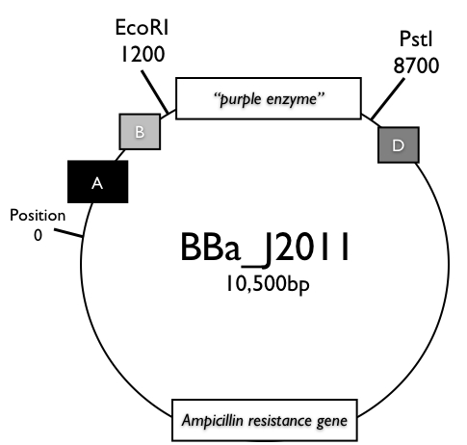

Alright. You’re almost ready for the digestion. Your *JAMT* gene is ready to go (i.e. it’s a nice small volume of clear liquid). But the BioBrick is in bacteria…

**Question 3.** *What is the name of the process that you will use to extract the BioBrick plasmid from the* E. coli*? Briefly describe the steps involved.*

Now the digest. You digest your *JAMT* DNA (from Question 2) and “purple enzyme” BioBrick DNA (in the figure on the previous page) with EcoRI and PstI. You run the products of each of the digests in a separate lane on a gel.

**Question 4a.** *Using the diagram below, draw what you expect your gel to look like. Show the DNA fragments at the appropriate length and at the proper positions on the gel.*

*Please draw your own DNA ladder on the left-most lane for reference. Label the lengths of the bands in the DNA ladder and your products.*

*Label how the electrodes are set up with respect to the gel below. Where is the positive (red) electrode and where is the negative (black) electrode?*

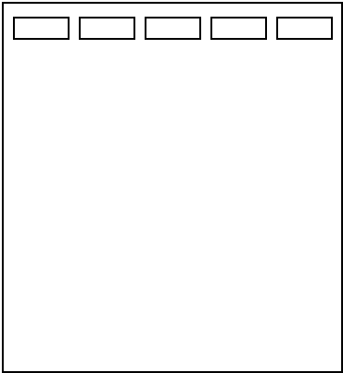

**Question 4b.** *Circle the products that you will use in the next cloning step: ligation.*

Ligation time!

**Question 5.** *Indicate the recipe for a ligation of the BioBrick backbone and your* JAMT *insert.* *Assume the* JAMT *insert is 1000 bp. Assume that all nucleotides are 1000 Da. Assume that you want 1 nM concentrations of each of the DNA components in your ligation.*

Plasmid (10 ng/μL) _____ μL

Insert (50 ng/μL) _____ μL

Ligation Buffer (10X) _____ μL

T4 DNA Ligase (Enzyme) _0.5 _ μL

Water _____ μL

Total _10_ μL

At this point, you have what you believe is the BioBrick device that will bring you glory, that is flowery-scented bacteria. But you won’t smell anything until you get your BioBrick back into *E. coli*! This is the process of **transformation** (which you will perform in lab today). You will have to select the bacteria that receive your BioBrick.

**Question 6.** *How can you verify that any bacteria have received your new BioBrick?*

You use the process from Question 6 to select the correct bacteria, grow a culture of those bacteria, and voila! *E. coli* with a faint bouquet of jasmine. You are very proud of yourself, so much so that you decide to enter your project into *iGEM* 2011. Go you.

1. This stands for SAM:***j***asmonic ***a***cid carboxyl***m***ethyl***t***ransferase.