Comparing Methods of Protein Immobilization on Gold Nanoparticles with Regards to Kinetics

The Danelmen Lab: Daniel-Mario Larco, Helen Slucher, and Zachary Mendel

American University, Washington, DC 20016

Abstract

In this project, three different methods of protein nanoparticle synthesis were investigated with regards to kinetics. These methods were the alpha, beta and gamma method. The alpha method involved a simple reduction of chloroauric acid by sodium citrate. The beta method took this one step further, by utilizing dopamine as a stabilizing agent. Lastly, the gamma method involved a novel approach using reactant free nanoparticles as the template for synthesis. To investigate these methods, the proteins horseradish peroxidase, and myoglobin in addition to hemoglobin were utilized. Only methods performed on HRP resulted in reproducible results. The methods performed on myoglobin and hemoglobin suggested the presence of functional protein nanoparticles but results were not reproducible. Future research could investigate myoglobin and hemoglobin protein nanoparticles and attempt to get reproducible results. This could be done through altering protein concentrations, pH, in addition to reaction temperature to name a few.

Introduction

Biomineralization and nanotechnology are two extremely active fields of research. In Biomineralization, proteins and peptides aggregate to form inorganic materials. In nanotechnology scientists explore the properties of materials on the nano scale. Gold nanoparticles are being extensively researched as a result of their unique optical-electronics properties. Possible practical applications of these particles include drug delivery in addition anticancer therapies¹.
The relationship between proteins and nanoparticles is being investigated as proteins play an important role in the synthesis of nanoparticles in addition to their stability in solution². Moreover, the different surface topologies of the protein alters characteristics of the nanoparticles such as hydrophilicity, colloidal stability in addition to compatibility³ ⁴. Moreover, the addition of functional proteins encapsulating nanoparticles has been investigated, as the proteins would provide a “bio-friendly” covering for the nanoparticles.
Previously it has been shown that these proteins can be encapsulated around gold nanoparticles, using heat in the synthesis mechanism. However, these proteins were not active. It was hypothesized that the heat most likely denatured the proteins, deeming them not functional. This project set out to evaluate three different methods of synthesizing protein nanoparticles without the addition of heat. Rather these methods synthesize nanoparticles through electrostatic interactions at lower temperatures. Moreover, while previously bovine serum albumin (BSA) was used as a reducing agent, in all but one of these methods sodium citrate was used as the reducing agent. The synthesis of citrate-protected nanoparticles does not require a lot of heat and is a relatively fast process⁵. For simplicity, the three methods were given the names alpha, beta, and gamma respectively, and will be described in the methods overview section of this report.

Materials and Methods

Overview

The alpha method was based off a 2001 Langmuir paper by Sastry⁶. In this method, gold nanoparticles were created by reducing chloroauric acid with sodium citrate. Proteins in a 10⁻⁶M buffer solution were then added to the nanoparticle solution yielding a protein nanoparticle solution. The final protein concentrations ranged from 10⁻⁶M to 10⁻⁸M.
The beta method was inspired from a Ji and Bao paper respectively³ ⁷. Similar to the alpha method, in the beta method, gold nanoparticles were synthesized through the reduction of chloroauric acid by sodium citrate. Contrary to the alpha method, the beta method employed polydopamine as a stabilizing agent, to facilitate the addition of the proteins. Proteins were then added in the similar manner as the alpha method.
Lastly, the gamma method utilizes reactant free nanoparticles as the substrate for the protein nanoparticles. While the previous methods use chemicals to synthesize nanoparticles, these nanoparticles are obtained through laser ablation⁸. As a result of this synthesis method, these nanoparticles are known to not contain impurities⁸. To attach the protein, it must be centrifuged for 30 minutes at a specified speed with the nanoparticle solution. These methods create protein nanoparticles through weak covalent interactions, thiolate linkages, catechol functionalization from dopamine, in addition to simple electrostatic interactions between the nanoparticles and the protein⁶ ³ ⁹.

Procedures

Gold nanoparticles, AuNPs, were made three different ways: alpha, beta, and gamma. Each set of AuNPs was coated with one of three proteins: horseradish peroxidase (HRP), hemoglobin, and myoglobin.

Gold Nanoparticles: Alpha, Beta, and Gamma
I. Alpha
1. Prepare stock solutions
a. Dissolve HAuCl₄ in water to have a solution of 10mM
b. Dissolve 250mg of the citrate sodium salt into 25mL of water
2. In a beaker mix 50mL of water and a volume of the gold stock solution
3. Bring solution to a boil
4. Add a volume of the citrate sodium solution and reflux for 30 minutes
a. Note color change from dark blue to red

II. Beta
1. Prepare stock solutions
a. Dissolve HAuCl₄ in water to have a solution of 10mM
b. Dissolve 250mg of the citrate sodium salt into 25mL of water
2. In a beaker mix 50mL of water and a volume of the gold stock solution
3. Bring solution to a boil
4. Add a volume of the citrate sodium solution and reflux for 30 minutes
a. Note color change from dark blue to red
Part 2)
1. Dissolve dopamine in 100mL Tris Buffer to have a 10mM solution at pH 8.5
2. Immediately mix 17mL of AuNP solution with 17mL of the dopamine solution
3. Stir under air at room temperature for 1 hour
4. Purify by centrifuging and then suspending in water or Tris buffer
5. Filtrate through filter paper with vacuum

III. Gamma
1. A 1/10 solution of the reactant-free nanoparticles was prepared from the stock solution
2. 27mL of the AuNP solution was transferred to a beaker
3. 1mL of 0.1mg/mL protein concentration in H₂O was added to the beaker
4. The mixture was stirred at room temperature for 30 minutes
5. The solution was then centrifuged for 30 minutes at 6,500g
6. The supernatant and pellet were separated
7. The pellet was suspended in PBS

Proteins: HRP, Hemoglobin, Myoglobin
I. Alpha
1. The protein stocks were prepared by dissolving protein in an acetate buffer with pH adjusted to be as close to the protein’s pI as possible
2. The final concentration of the protein stocks was about 0.1mg per mL
3. A 1:10 and 1:100 AuNP to protein volume ratio was prepared
4. Solutions were stored in the refrigerator

II. Beta
1. The protein stocks were prepared by dissolving protein in 50mM Tris buffer with pH adjusted to be as close to the protein's pI as possible
2. The final concentration of the protein stocks was about 0.1mg per mL
3. A 1:10 and 1:100 AuNP to protein volume ratio was prepared
4. The solutions were left to incubate at room temperature for 30 minutes
5. The solutions were then placed in the centrifuge for 30 minutes at 6,500g
6. The supernatant and pellet were separated and the pellet suspended in PBS buffer
7. Both sets of solutions were placed in the refrigerator until ready for testing

III. Gamma
Part 1)
Determine amount of protein needed to saturate and stabilize the reactant-free AuNPs
1. Transfer 250μL of suspended AuNPs and place in 1.5mL Eppendorf tube
2. Adjust pH of the gold colloid to match the isoelectric point of the protein to be conjugated
3. Add between 0 and 1mg of protein in 25μL to the AuNPs
4. Incubate for 2-3 minutes at room temperature
5. Add 250uL of 10% NaCl solution
6. Observe color change and determine at which protein concentration the AuNP surface is saturated and no aggregation occurs. This can be observed by an increase in absorbance at 580nm

Part 2)
Preparation of the AuNP conjugate
1. Transfer the amount of AuNPs needed from the stock to a new tube
2. Add the protein amount plus an additional 10%
3. Incubate for 30 minutes at room temperature
4. Centrifuge the solution for 30 minutes at the appropriate speed for the gold nanoparticle size used (Table 1.)
5. Suspend pellet in PBS supplemented with 0.1% BSA or 1% PEG.
6. Store at 4˚C

Table 1. The size of gold nanoparticles and corresponding centrifuge speed
Size (nm) | Speed (g)
15 | 17,000
20 | 4,500
45 | 2,000
60 | 1,125
80 | 600
100 | 400
150 | 180
200 | 100

IV. Testing HRP
1. The HRP-AuNPs complex solutions were placed in high velocity tubes
2. The nanoparticle solutions were spun at 18,000rpm for 3 hours
3. The supernatants were discarded and the pellets were suspended in water
4. The AuNPs were stored at 4˚C
5. The suspended HRP-AuNP complex solutions were analyzed for activity using UV-Vis
a. The nanoparticles were added to H₂O₂ and ophenylenediamine (OPD)
b. Active HRP catalyzes the reaction of OPD with H₂O₂ to produce 2,3-Diaminophenazine (Figure 1.)

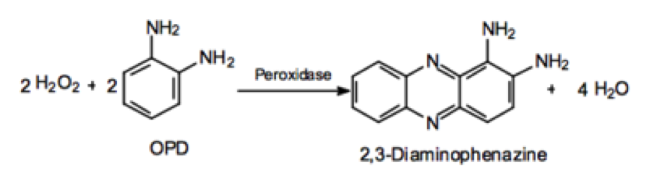

Figure 1. The reaction of OPD to 2,3-Diaminophenazine catalyzed by active HRP

V. Testing Hemoglobin and Myoglobin
The alpha, beta, and gamma method AuNPs, coated with hemoglobin and myoglobin, were tested using Ocean Optics Spectroscopy.
1. The HRP-AuNPs complex solutions were placed in high velocity tubes
2. The nanoparticle solutions were spun at 18,000rpm for 3 hours
3. The supernatants were discarded and the pellets were suspended in Tris or PBS (depending on method)
4. The AuNPs were stored at 4˚C
5. 50mM Tris buffer solution prepared at pH ~7*
6. 10mM sodium dithionite solution prepared in Tris buffer*
7. Solutions degassed for ~3 hours
8. Ocean optics spectra of mixture of protein AuNPs with sodium dithionite over 5 seconds
Sodium Dithionite strips oxygen away from myoglobin and hemoglobin. The protein now without oxygen present in their Heme groups, shows absorbance ~30nm to the right. This shift is observed and compared between methods.
*Both solutions prepared fresh everyday of testing.

Results
HRP
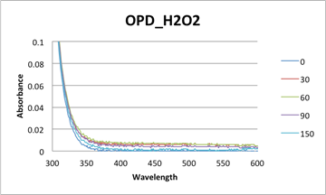

Figure 2. Absorbance spectra for OPD and H₂O₂ (uncatalyzed).

Alpha method:
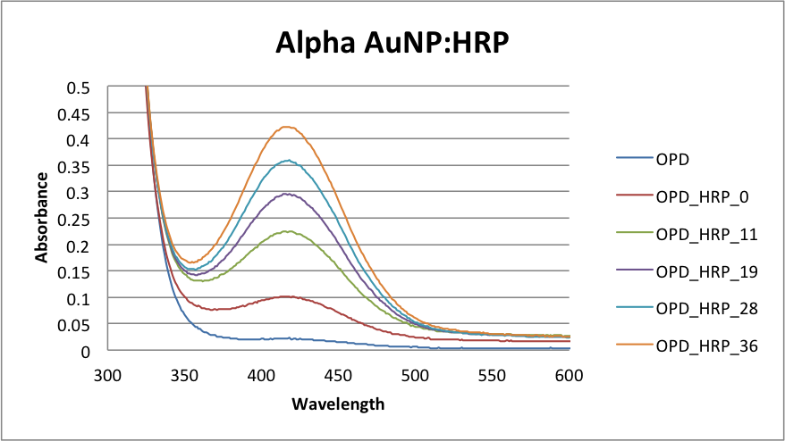
Figure 3a. Absorbance spectra for H₂O₂, OPD and an aliquot from the alpha HRP pellet

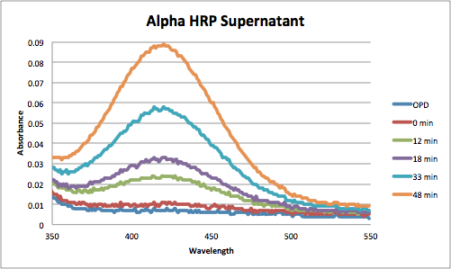
Figure 3b. Absorbance spectra for H₂O₂, OPD and an aliquot from the alpha HRP supernatant.

Beta method
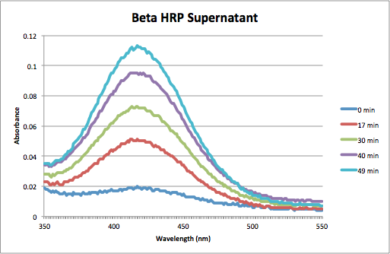
Figure 4a. Absorbance spectra for H₂O₂, OPD and an aliquot from the beta HRP supernatant.

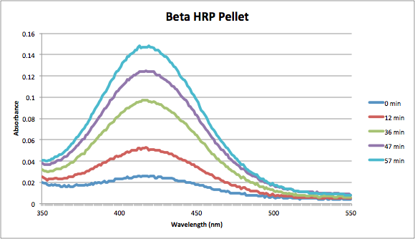
Figure 4b. Absorbance spectra for H₂O₂, OPD and an aliquot from the beta HRP pellet

Gamma method
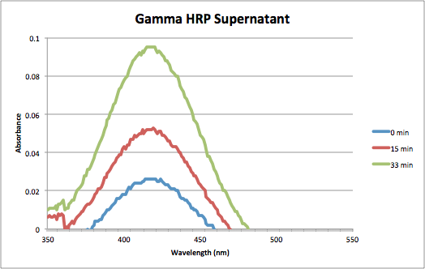
Figure 5a. Absorbance spectra for H₂O₂, OPD and an aliquot from the alpha HRP Supernatant
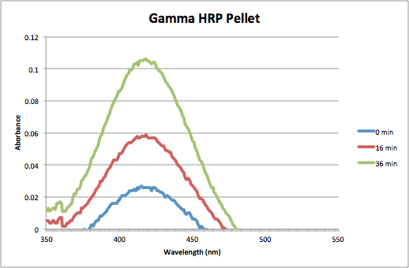
Figure 5b. Absorbance spectra for H₂O₂, OPD and an aliquot from the gamma HRP pellet
These results indicate that in both the pellets and supernatants of all three methods there was active HRP molecules that catalyzed the OPD conversion to 2,3 Diaminophenazine. The absorbance over time increased significantly and the reaction occurred much than in the uncatalyzed reaction, which after many minute still had not increased by much. The best way to compare the pellets to the supernatants and even the methods would have been to calculate the concentrations of the peaks over time and compare. But according to Ohlsson et al. HRP does not obey beer’s law and therefore the concentrations could not be calculated for comparison purposes¹⁰.

Myoglobin

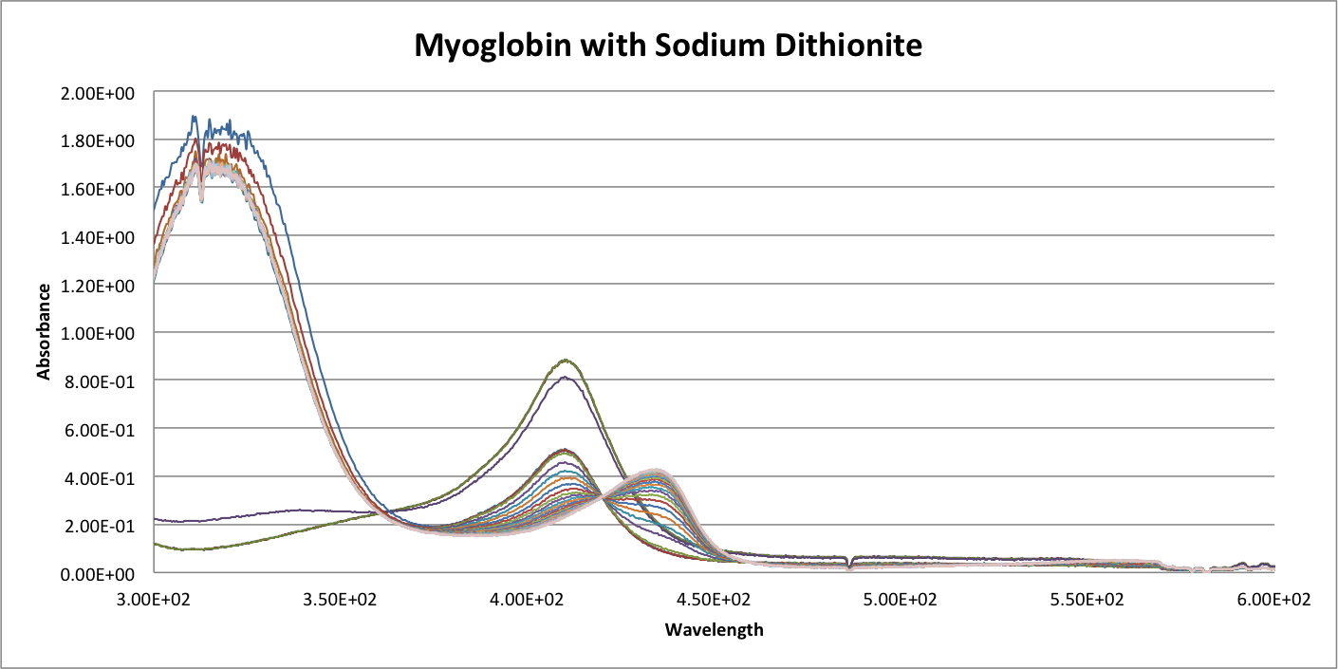
Figure 6. Hemoglobin absorbance spectra upon addition of sodium dithionite
The addition of sodium dithionite to a myoglobin solution reveals a decrease in peak at ~415 nm and an increase in peak at ~ 440 nm.

Alpha method
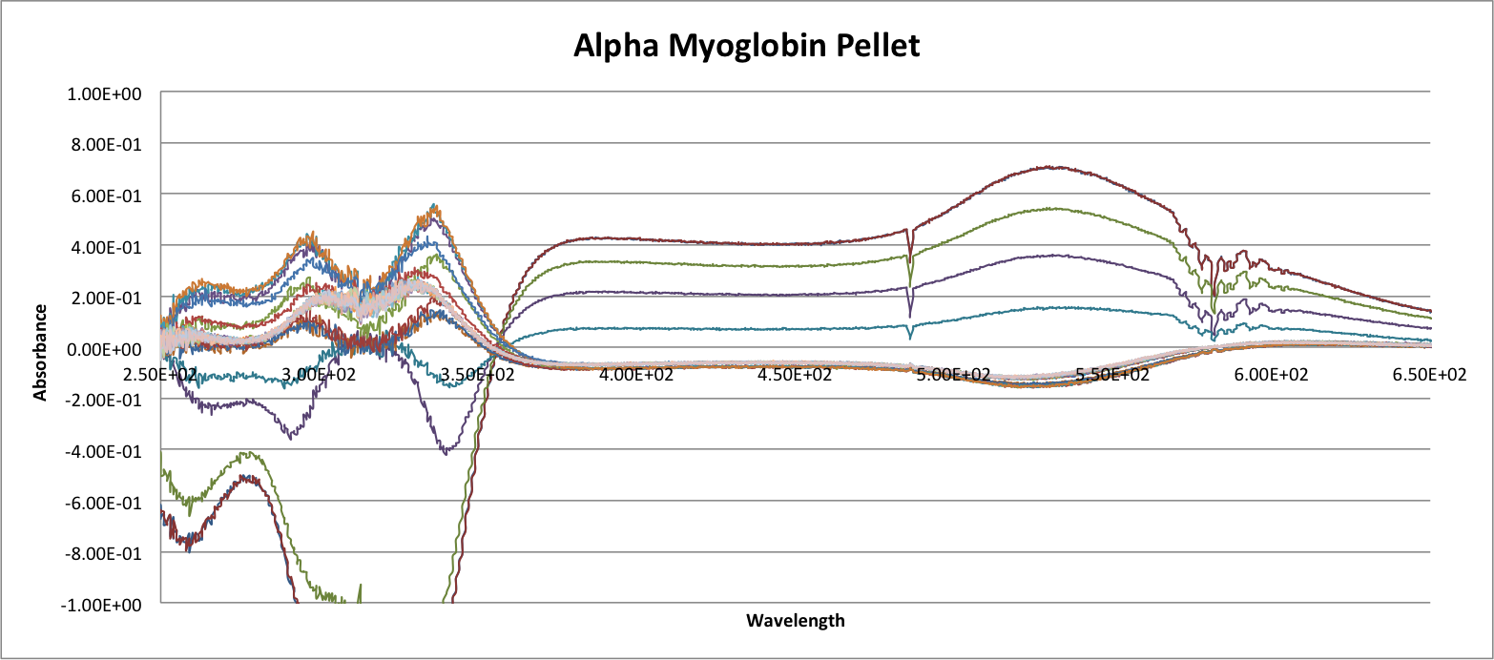
Figure 7. Continuous absorption spectra of Alpha Myoglobin pellet reacting with Sodium Dithionite.

Beta method
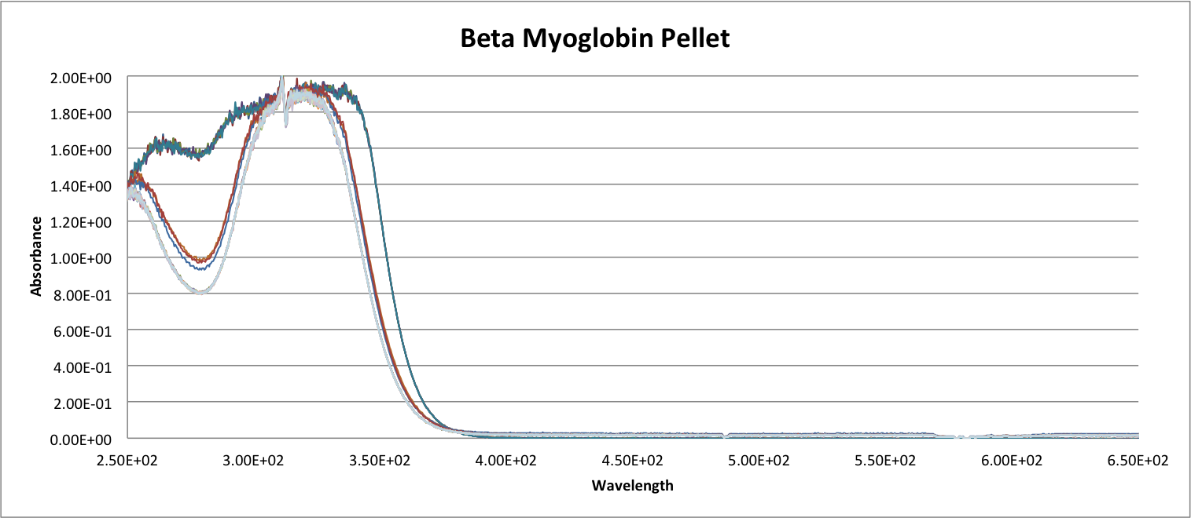
Figure 8. Continuous absorption spectra of Beta Myoglobin pellet reacting with Sodium Dithionite.

The supernatant spectra were similar to that of the pellet.

Gamma method
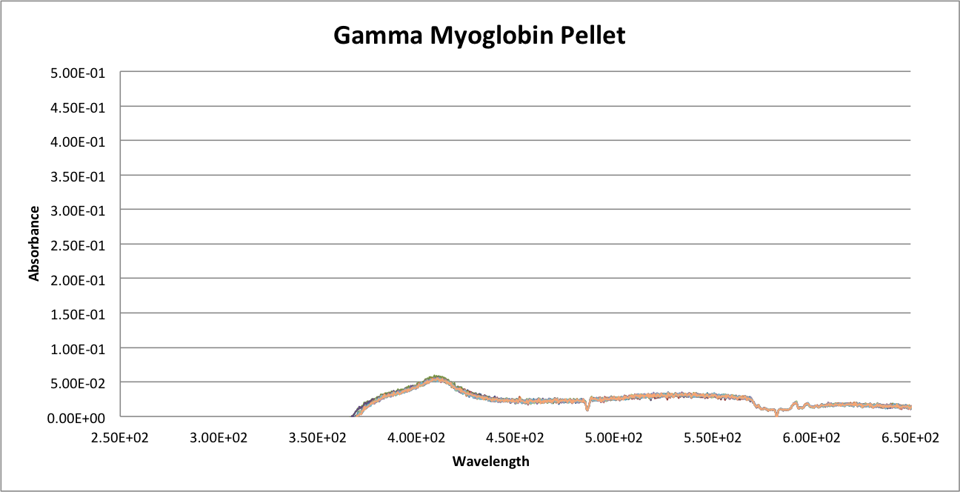
Figure 9. Continuous absorption spectra of Gamma Myoglobin pellet reacting with Sodium Dithionite.

The supernatant spectra were similar to that of the pellet.
For myoglobin, these figures indicate no evidence of active myoglobin molecules in either the pellets or the supernatants. In some cases, the spectra showed no absorption at ~415 nm when the solutions were added. This is a sign that no myoglobin was present in the solutions. In the alpha method, a very concentrated solution of Myoglobin coated AuNPs was tested and the results from figure 7 show that there is absorption throughout the spectrum but does not qualify as evidence as there was no increase and decrease in peaks. The gamma method produced the best results as seen in figure 9. The latter shows that there is a peak at ~415 nm but there is no evidence of peak shifting.

Hemoglobin

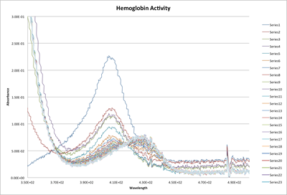
Figure 10. Hemoglobin absorbance spectra upon addition of sodium dithionite
Just as in myoglobin, upon addition of sodium dithionite, there is a shift in peak form ~400 nm to ~430 nm. This figure shows how this shift occurs over the span of 5 seconds.

Alpha method
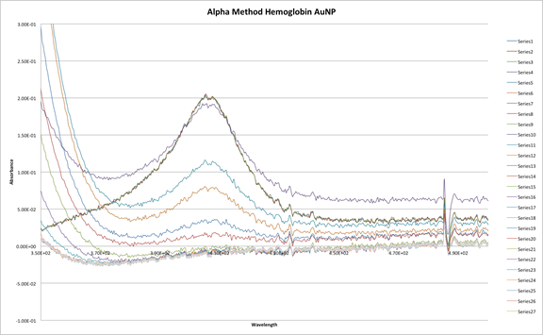
Figure 11. Absorbance spectra for alpha hemoglobin nanoparticles upon addition of sodium dithionite

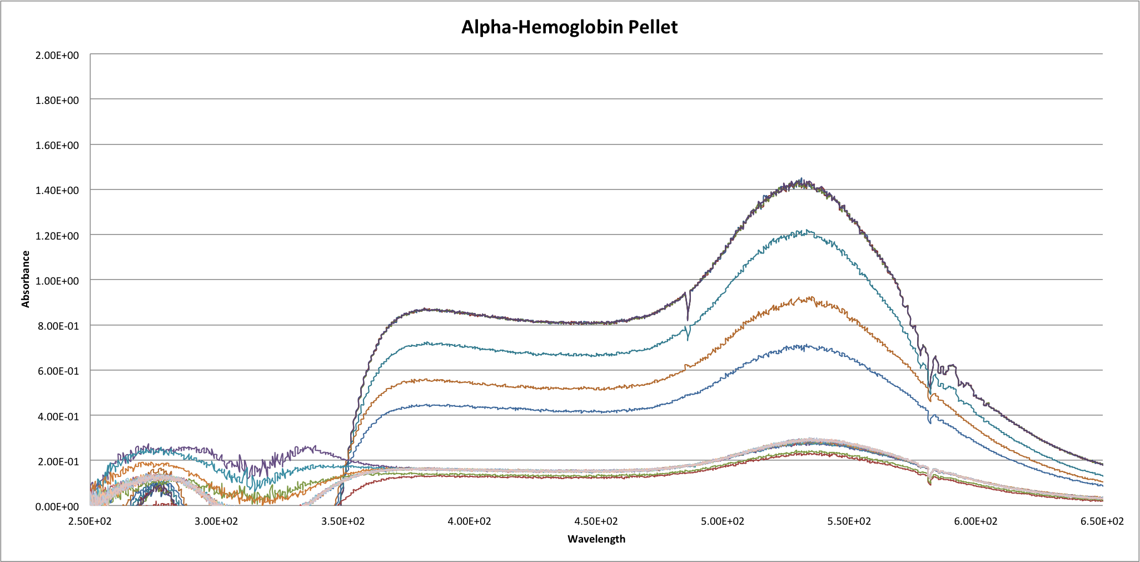
Figure 12. Absorbance spectra for alpha hemoglobin nanoparticles upon addition of sodium dithionite

Beta method
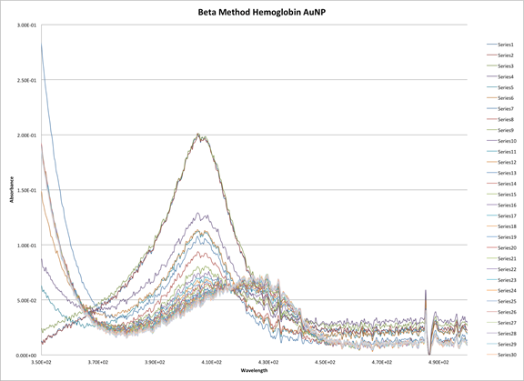
Figure 13. Absorbance spectra for beta hemoglobin nanoparticles upon addition of sodium dithionite
These spectra indicate that there is hemoglobin present in the beta method hemoglobin solution and upon the addition of dithionite, there was a shift in peak from ~400 nm to ~430 nm, sign of Hemoglobin activity.

Gamma method

For this method, there were no recorded spectra. This is because when the samples were run in the ocean optics spectrometer, there was no absorbance indicating the presence of anything. The spectra were similar to myoglobin’s form the beta method. (Figure 8.)

Alpha and Beta Method AuNPs
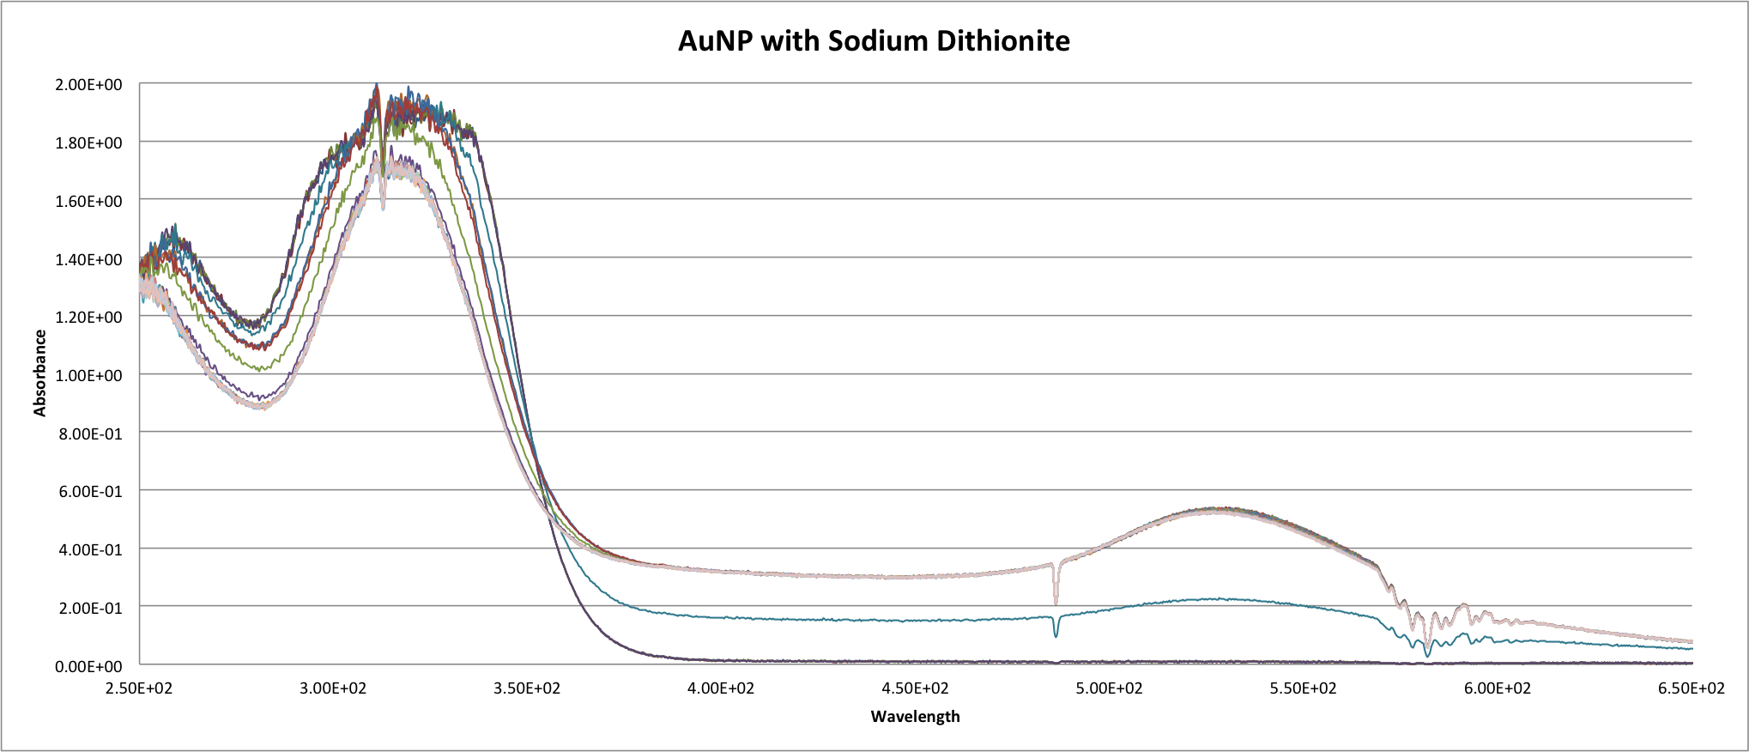
Figure 14. Alpha Method AuNPs reacted with Sodium Dithionite

In the concentrated conjugates formed following the alpha method, there was a lot of absorbance throughout the spectrum. In order to remove background noise and test if nanoparticles reacted with the dithionite solution, spectra were recorded over a period of 5 seconds of the reaction of citrate protected AuNPs with Sodium Dithionite. The results are seen in figure 14. This data was used to remove absorbance from AuNPs in the alpha and method myoglobin and hemoglobin concentrated solutions (Figures 7 and 12).

Kinetics for HRP samples

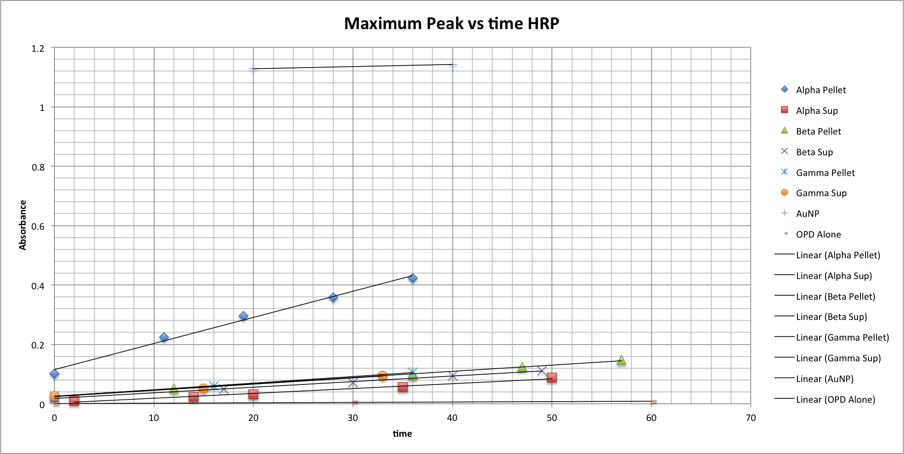
Figure 15. Linear representations of maximum absorbance of HRP:AuNP versus time all methods.

In this figure, the absorbance of the pellet and supernatant solutions at 418 nm were recorded and graphed with respect to the time in minutes after the OPD and peroxide were mixed with the samples. This graph reveals that all samples, including pellets and supernatants, for all methods showed activity with a faster rate of absorbance increase over time compared to the OPD and peroxide alone. Of all the samples, it was the Alpha method HRP:AuNP that showed the best rate of increase and therefore the most successful method for HRP:AuNP conjugate formation.
Discussion

Figure 3a reveals that the alpha method HRP nanoparticles contained active HRP. This is known because there is marked increase in absorbance over time for the pellet compared to simply OPD and H₂O₂. Figure 2 reveals the changes in absorbance for the mixture of OPD and H₂O₂ without a catalyst. In order to determine whether the results were from active HRP nanoparticles or simply free HRP in the pellet, UV-Vis was run on the supernatant as well. Figure 3b shows that although there were increases in absorbance over time for the supernatant, they were smaller increases compared to the pellet. It is hypothesized that because there are different absorbance spectra for the pellet in addition to the supernatant, the content of both solutions are different. Since centrifugation is supposed to separate things based on weight, it is plausible that the difference in absorbance can be attributed to the fact that one solution (the pellet) contains HRP nanoparticles whereas the supernatant contains free HRP molecules. However, it is also possible that the two solutions contain different absorbance spectra due to the fact that they contain different levels of HRP in the same form.
To prove that the pellet was indeed nanoparticles and not free protein, solutions of HRP, myoglobin, in addition to hemoglobin were spun down at the same speeds as for the nanoparticle conjugate solutions. No precipitate was formed after these centrifugations; thus, it can be inferred that the pellets were indeed nanoparticle conjugates.
In order to show that there was indeed active HRP nanoparticles in the pellet, rather than simply some free HRP present from leftover supernatant, the pellet was spun down again and then suspended. However, upon suspending this pellet again, there was not enough pellet to be detected using UV-Vis. It is hypothesized that whatever pellet was left over was simply stuck to the centrifuge tubes. Whatever concentration of pellet that was suspended was in such a low concentration that it could not be detected using UV-Vis.
The beta and gamma method HRP solutions both showed activity; however, similar to the alpha nanoparticles, this activity cannot be conclusively attributed to active HRP nanoparticles. Unlike the alpha nanoparticles, there was not much of a difference in absorbance spectra for the supernatant solution and the pellet solution. Once again, in order to conclusively show what was seen in the pellet solution was indeed HRP nanoparticles the pellet solution needed to be centrifuged again and then suspended. This process was attempted; however, the same problem with the alpha method also occurred in the beta and gamma method. That is, after suspending the pellet, there was not enough protein in the solution to detect.
It was hypothesized that this could be corrected by increasing the concentration of the nanoparticles, prior to spinning the solution down for a second time. This hypothesis was tested out with the proteins myoglobin and hemoglobin; the results of which will be discussed later in this section.
For hemoglobin, activity was seen only in the beta method. Moreover, this result was not reproducible. Figure 13 reveals the positive activity of the hemoglobin nanoparticles. This can be seen by the decrease in absorbance around 400nm coinciding with an increase in absorbance around 430nm. This increase in absorbance at 430nm is from hemoglobin without oxygen bound to the heme. The gamma and alpha method of the hemoglobin however did not show similar results throughout the semester. In fact, many times nothing was detected in the pellet or the supernatant. In order to fix this issue, the nanoparticle and protein solutions were added in higher concentrations. This resulted in a much denser pellet that did show up on the spectra. However, the absorbances that were recorded do not indicate the presence and activity of active Hemoglobin molecules. As seen in figures 7 and 12, there was no peak around 400nm. Instead there was a peak around 550nm, which isn’t identified at this time. It can possibly be from the nanoparticle solution as figure 14 shows a similar peak for a solution of citrate protected AuNPs.

Conclusion

In brief, only methods performed on HRP resulted in reproducible results. The methods performed on myoglobin and hemoglobin suggested the presence of functional protein nanoparticles but results were not reproducible. Future research could investigate myoglobin and hemoglobin protein nanoparticles and attempt to get reproducible results. This could be done through altering protein concentrations, pH, in addition to reaction temperature to name a few.

References

1. Hyeon, T. K. a. T., Applications of inorganic nanoparticles as therapeutic agents. Nanotechnology 2013, 25.
2. Matthew R Hartings, N. B., Floriene Briere, Maria Briscione, Omar Choudary, Tamra L Fisher, Laura Flynn, Elizabeth Ghiias, Michaela Harper, Nader Khamis, Catherine Koenigsknecht, Klare Lazor, Steven Moss, Elaine Robbins, Susan Schultz, Samiye Yaman, Luke M Haverhals, Paul C Trulove, Hugh C De Long, Abigail E Miller and Douglas M Fox, Biomineralization of Gold from a solution of Au3+ and Bovine Serum Albumin. Science and Technology of Advanced Materials 2013, 14.
3. Xiangsheng Liu, J. C., Huan Li, Jianyu Li, Qiao Jin, Kefeng Ren, and Jian Ji, Mussel-Inspired Polydopamine: A Biocompatible and Ultrastable Coating for Nanoparticles in Vivo. American Chemical Society 2013, 7 (10), 9384-9495.
4. Saurabh Gautam, P. D., Munishwar N. Gupta, A facile and green ultrasonic-assisted synthesis of BSA conjugated silver nanoparticles. Colloids and Surfaces B: Biointerfaces 2013, 102.
5. A D McFarland, C. L. H., C A Mirkin, R P Van Duyne, and H A Godwin, Citrate Synthesis of Gold Nanoparticles 2004.
6. Anand Gole, C. D., Vidya Rumakrishnan, S R Sainkar, A B Mandale, Mala Rao, and Murali Sastry, Pepsin-Gold Colloid COnjugates: Preparation, Characterization, and Enzymatic Activty. Langmuir 2000, 17, 1674-1679.
7. Xu, Y.; Palchoudhury, S.; Qin, Y.; Macher, T.; Bao, Y., Make Conjugation Simple: A Facile Approach to Integrated Nanostructures. Langmuir 2012, 28 (23), 8767-8772.
8. Gold Nanoparticles. (accessed March).
9. Smita Thobhani, S. A., Robert Boyd, Neelam Kumarswami, James Noble, Mateusz Szymanski, and Robert Porter, Bioconjugation and characterisation of gold colloid-labelled proteins. Journal of Immunological Methods 2010, 356, 60-69.
10. Peroxidase, T. M. A. o. H., PI Ohlsson and KG Paul. Acta Chem 1976, 30 (4).

