Transect # 2
Dave Mohebbi and Sophia Comas

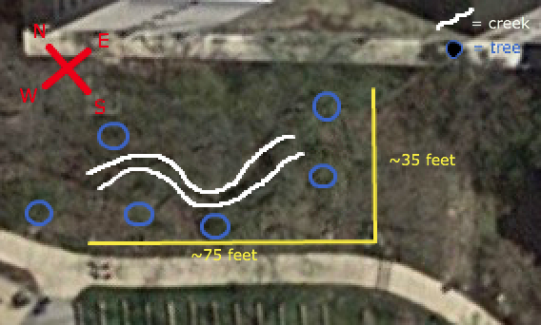

Transect # 2 is located just Northeast of the amphitheater, and consists of a moderately wooded area with a small, clear creek running through it. The land is not flat. The length of creek is the lowest point of elevation throughout the transect, with both banks rising on each side. The creek runs from the Southeast to the Northwest.

The exact boundaries of the transect area as of now unknown, as the popsicle sticks marking the boundaries were not seen.

The major biotic components of the transect are trees (marked on the map with blue circles), and grasses and bushes and small shrubbery, visible in green along the entirety of the creek. There are also many forms of wildlife, such as insects and birds, as well as lichens and algae growths on the rocks forming the creek bed. Due to the time of year, there is also an ample covering of dead leaves across most areas.

The major abiotic component of the transect is the creek itself, which runs clear and seemingly clean along the length of the transect. The creek bed is primarily stone, with rocks of many sizes and compositions, and there is a fair amount of trash and otherwise non-natural items, such as bricks, discarded food containers, and plastic bags. These are distributed relatively randomly throughout the transect.

