== Sending Images to Box ==
1. First click on the folder that you would like to transfer offline to BOX.
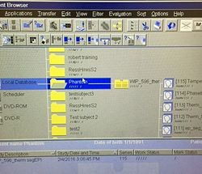

2. Once folder is highlighted click on the 'Transfer' tab in patient browser window and click Export to Offline.
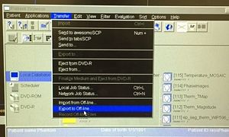

3. This will open a window. Click "\\mrisrv\scans" under path
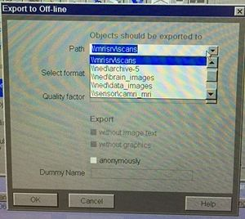

4. Add a Forward slash (\) and type your PI name and another (\) and type name of folder you are sending. Ex: \\mrisrv\scans'''\CAMRI\Phantom'''
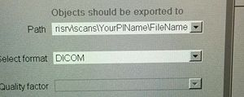

5. Hit 'OK' and another window will pop up telling you that this path does not exist and would you like to create it, click yes.

'''If your lab does not have a Box account set up with us please contact Dave Lee at dlee@bcm.edu and he will set that up for you.'''

