Instruction manual for PCR- based diagnostic system
- Before beginning the PCR testing, you will first make sure that all 96 test tubes are in the well plate. Since the test tubes are color coded decided which color will represent which data.
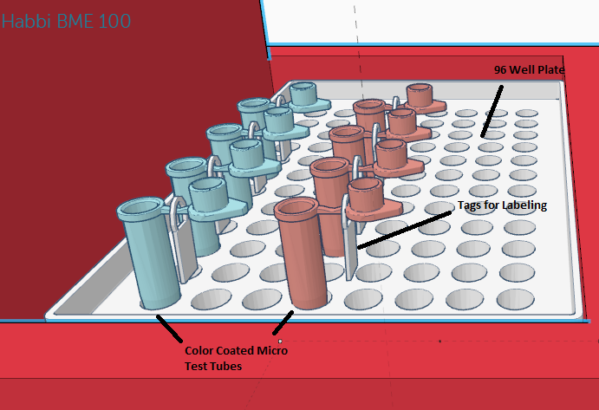

- The black USB cable will need to be connected into the designated slot on the machine and into the computer before the test is ran. This allows the computer to pick up all data of the PCR samples.
- The software on the computer must be in ‘testing mode’ to collect the data
- When the primers are in the test tubes and ready the heating lid can be closed
- After the lid has been closed click the green play button on the computer to allow for data collection. The green play button will turn into a red stop button indicating data collection will begin.

- The small red switch on the machine can be switched ‘ON’ so that the ‘O’ is pushed down
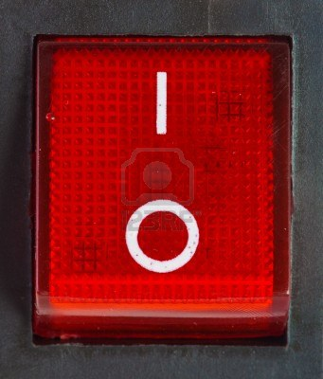
- The process should take about an hour, but the time remaining can be seen on the small screen of the machine.
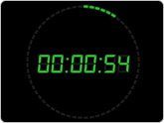

- Once testing has been completed data collection on the computer will automatically stop with the machine. Push the stop button on the computer software.
- Next, on the machine have the switched turn to off so that the ‘l’ is pushed down

- Finally the lid can be opened and the test tubes can evaluated.

*CAUTION- The machine can move a lot during the actual testing so make sure the device is on a solid flat surface

