20130618
1.calc_phos_DNA_no_citrate
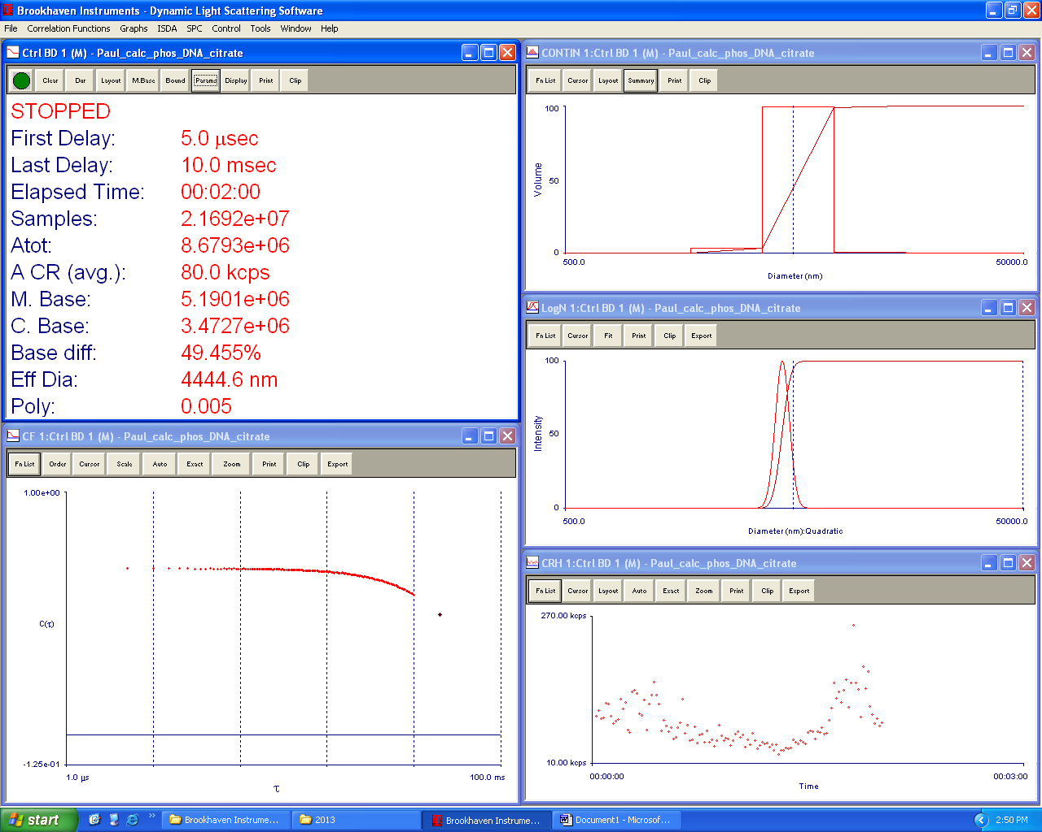
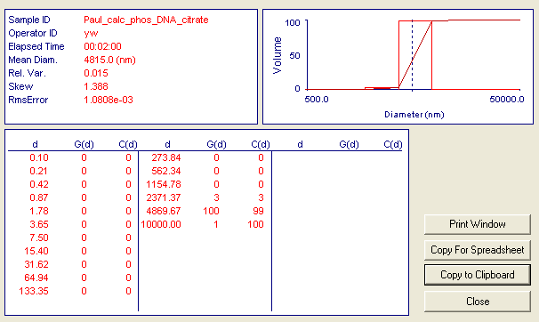
1.000000e-01, 0.000000e+00, 0.000000e+00
2.053525e-01, 0.000000e+00, 0.000000e+00
4.216965e-01, 0.000000e+00, 0.000000e+00
8.659643e-01, 0.000000e+00, 0.000000e+00
1.778279e+00, 0.000000e+00, 0.000000e+00
3.651741e+00, 0.000000e+00, 0.000000e+00
7.498941e+00, 0.000000e+00, 0.000000e+00
1.539926e+01, 0.000000e+00, 0.000000e+00
3.162277e+01, 0.000000e+00, 0.000000e+00
6.493816e+01, 0.000000e+00, 0.000000e+00
1.333521e+02, 0.000000e+00, 0.000000e+00
2.738419e+02, 0.000000e+00, 0.000000e+00
5.623412e+02, 0.000000e+00, 0.000000e+00
1.154782e+03, 0.000000e+00, 0.000000e+00
2.371373e+03, 3.461586e+00, 3.327201e+00
4.869674e+03, 1.000000e+02, 9.944502e+01
9.999998e+03, 5.773910e-01, 1.000000e+02

2. num_4 CPNP microemulsion. Diluted 2x
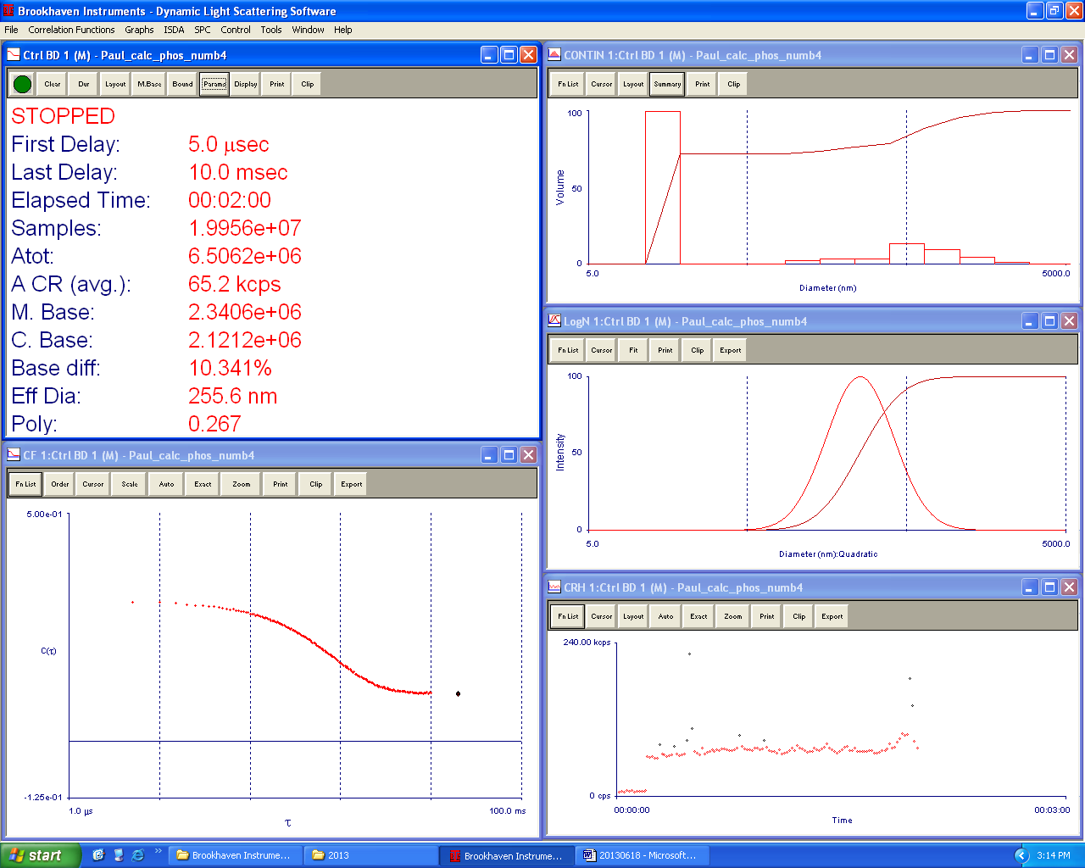

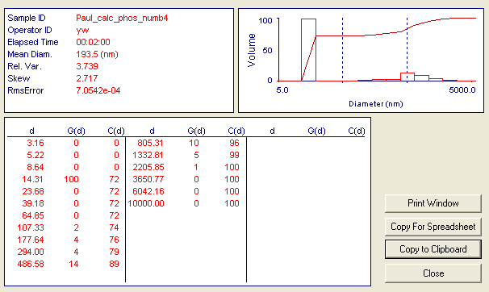
3.155556e+00, 0.000000e+00, 0.000000e+00
5.222562e+00, 0.000000e+00, 0.000000e+00
8.643536e+00, 0.000000e+00, 0.000000e+00
1.430537e+01, 1.000000e+02, 7.192394e+01
2.367593e+01, 0.000000e+00, 7.192394e+01
3.918454e+01, 0.000000e+00, 7.192394e+01
6.485188e+01, 0.000000e+00, 7.192394e+01
1.073323e+02, 2.446012e+00, 7.368321e+01
1.776389e+02, 3.833525e+00, 7.644043e+01
2.939990e+02, 3.558621e+00, 7.899994e+01
4.865793e+02, 1.354079e+01, 8.873900e+01
8.053068e+02, 9.787602e+00, 9.577863e+01
1.332813e+03, 4.504899e+00, 9.901873e+01
2.205855e+03, 1.364324e+00, 1.000000e+02
3.650772e+03, 0.000000e+00, 1.000000e+02
6.042163e+03, 0.000000e+00, 1.000000e+02
1.000000e+04, 0.000000e+00, 1.000000e+02

3. Citrate no DNA
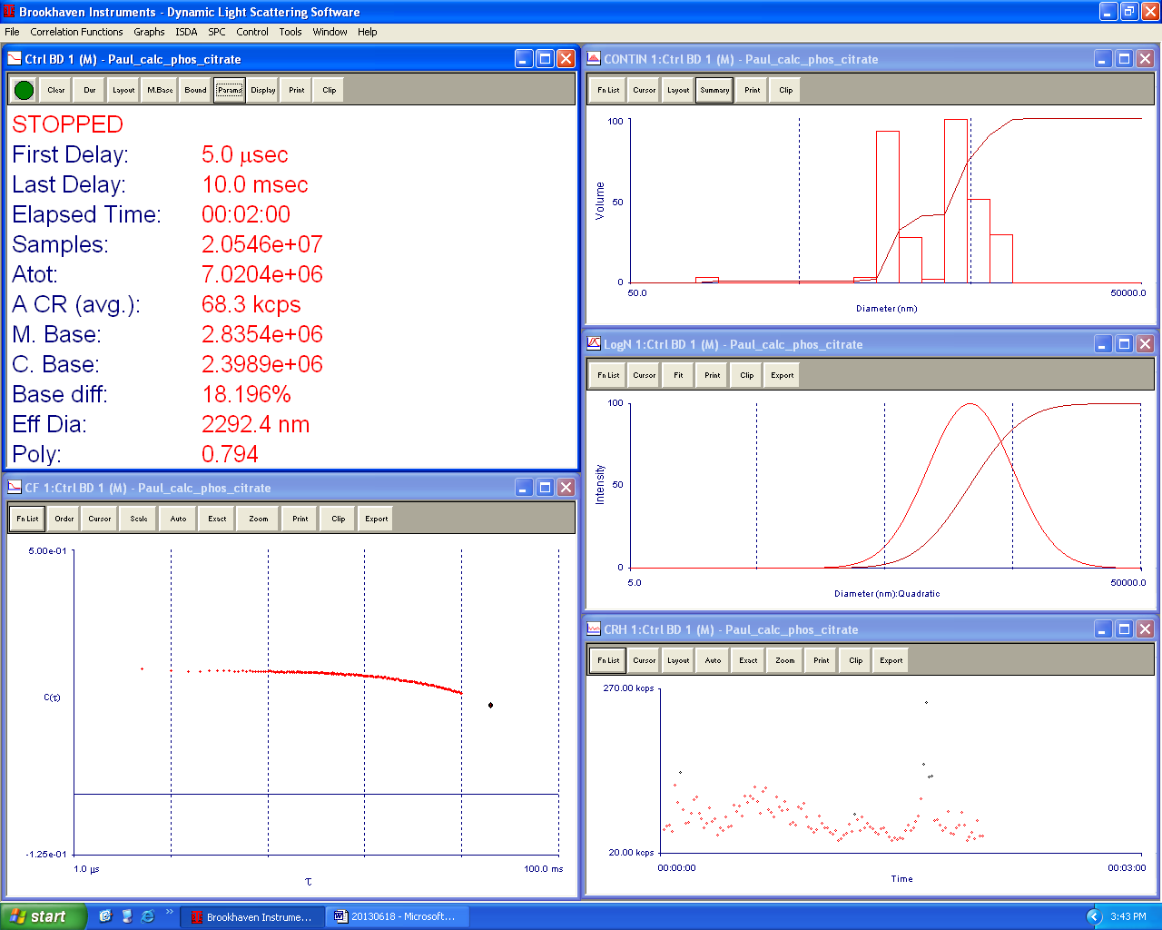
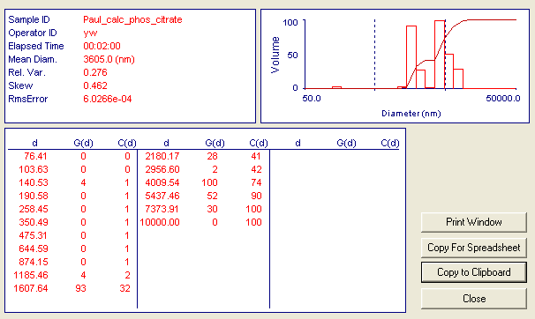
7.641334e+01, 0.000000e+00, 0.000000e+00
1.036266e+02, 0.000000e+00, 0.000000e+00
1.405313e+02, 3.575547e+00, 1.143748e+00
1.905789e+02, 0.000000e+00, 1.143748e+00
2.584502e+02, 0.000000e+00, 1.143748e+00
3.504926e+02, 0.000000e+00, 1.143748e+00
4.753141e+02, 0.000000e+00, 1.143748e+00
6.445886e+02, 0.000000e+00, 1.143748e+00
8.741472e+02, 0.000000e+00, 1.143748e+00
1.185459e+03, 3.866375e+00, 2.380525e+00
1.607639e+03, 9.289874e+01, 3.209701e+01
2.180170e+03, 2.819646e+01, 4.111650e+01
2.956598e+03, 2.437425e+00, 4.189619e+01
4.009537e+03, 1.000000e+02, 7.388423e+01
5.437460e+03, 5.166597e+01, 9.041116e+01
7.373914e+03, 2.961775e+01, 9.988530e+01
9.999999e+03, 3.585683e-01, 1.000000e+02

4. DNA + citrate
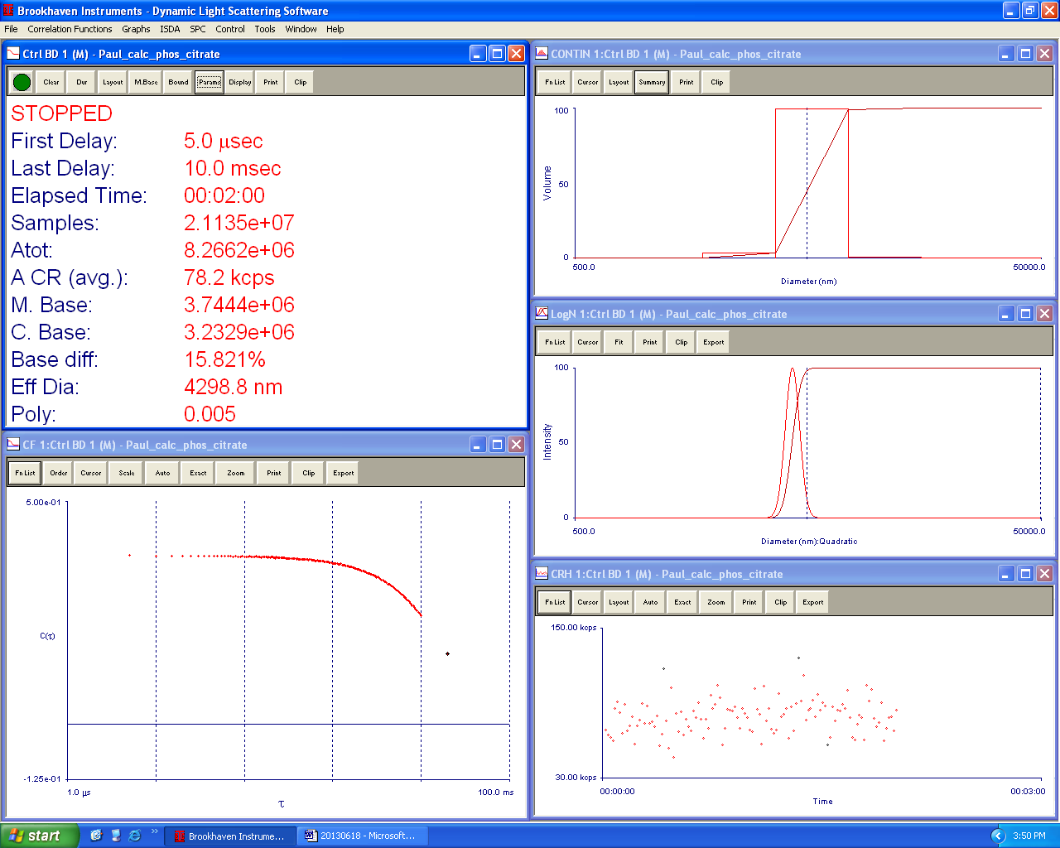
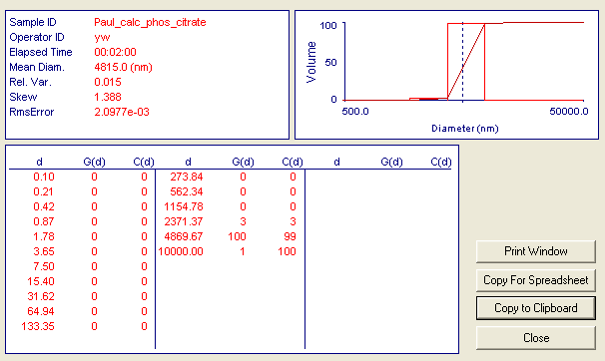
1.000000e-01, 0.000000e+00, 0.000000e+00
2.053525e-01, 0.000000e+00, 0.000000e+00
4.216965e-01, 0.000000e+00, 0.000000e+00
8.659643e-01, 0.000000e+00, 0.000000e+00
1.778279e+00, 0.000000e+00, 0.000000e+00
3.651741e+00, 0.000000e+00, 0.000000e+00
7.498941e+00, 0.000000e+00, 0.000000e+00
1.539926e+01, 0.000000e+00, 0.000000e+00
3.162277e+01, 0.000000e+00, 0.000000e+00
6.493816e+01, 0.000000e+00, 0.000000e+00
1.333521e+02, 0.000000e+00, 0.000000e+00
2.738419e+02, 0.000000e+00, 0.000000e+00
5.623412e+02, 0.000000e+00, 0.000000e+00
1.154782e+03, 0.000000e+00, 0.000000e+00
2.371373e+03, 3.461586e+00, 3.327201e+00
4.869674e+03, 1.000000e+02, 9.944502e+01
9.999998e+03, 5.773910e-01, 1.000000e+02

5. Num3 microemulsion without DNA
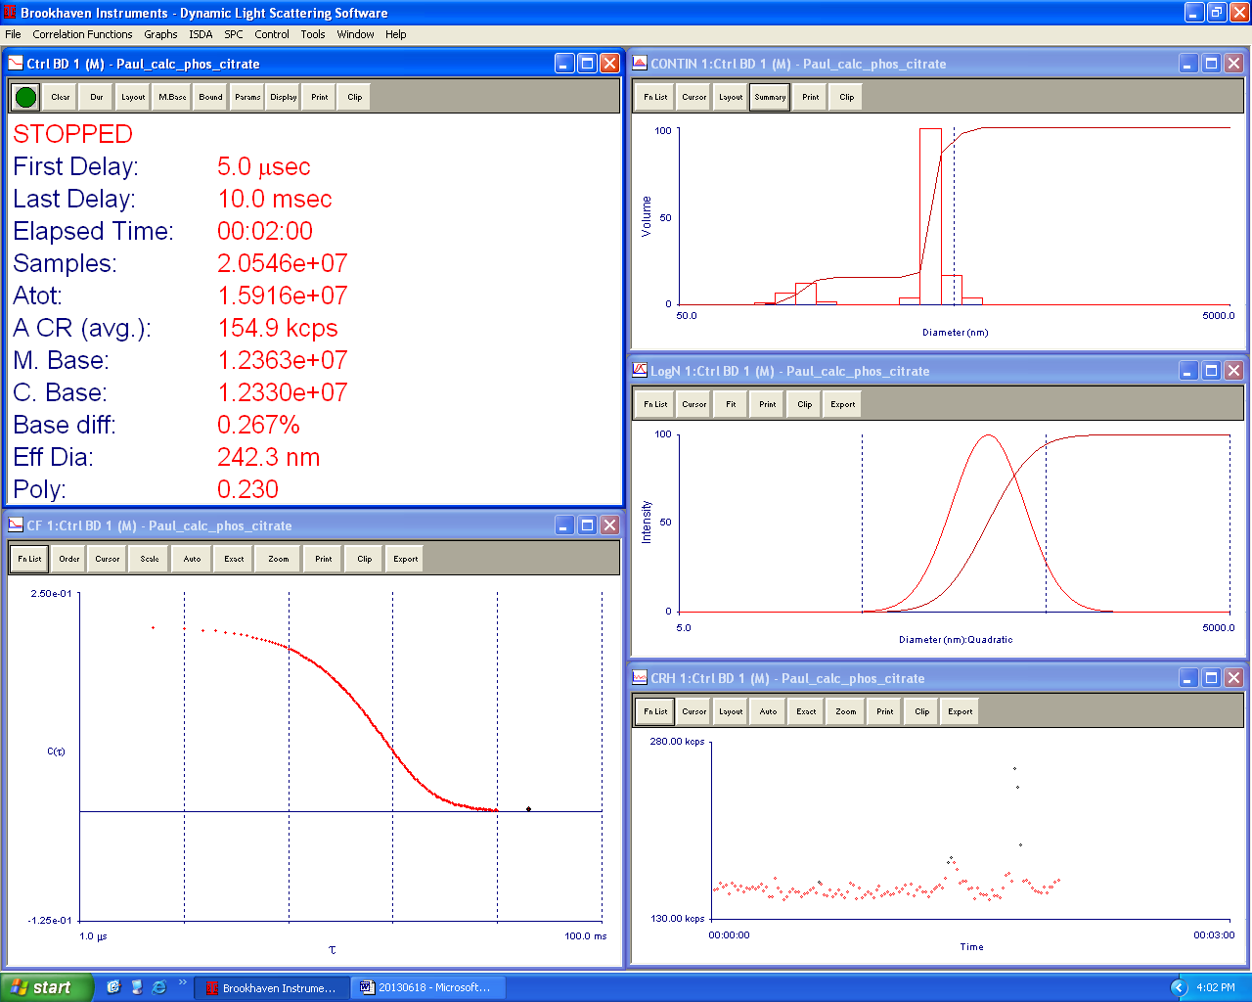
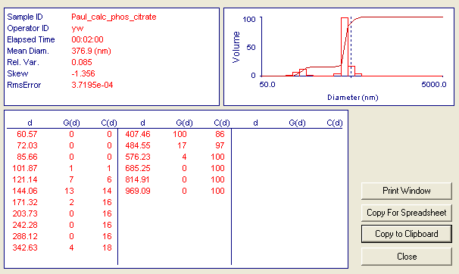
6.057000e+01, 0.000000e+00, 0.000000e+00
7.203014e+01, 0.000000e+00, 0.000000e+00
8.565858e+01, 0.000000e+00, 0.000000e+00
1.018656e+02, 1.459071e+00, 9.823780e-01
1.211391e+02, 7.127168e+00, 5.781029e+00
1.440592e+02, 1.257276e+01, 1.424614e+01
1.713158e+02, 2.026008e+00, 1.561024e+01
2.037296e+02, 0.000000e+00, 1.561024e+01
2.422763e+02, 0.000000e+00, 1.561024e+01
2.881161e+02, 0.000000e+00, 1.561024e+01
3.426290e+02, 4.149089e+00, 1.840377e+01
4.074561e+02, 1.000000e+02, 8.573277e+01
4.845487e+02, 1.707048e+01, 9.722615e+01
5.762277e+02, 4.119838e+00, 1.000000e+02
6.852527e+02, 0.000000e+00, 1.000000e+02
8.149058e+02, 0.000000e+00, 1.000000e+02
9.690898e+02, 0.000000e+00, 1.000000e+02

6/19 Paul

1. Citrate?
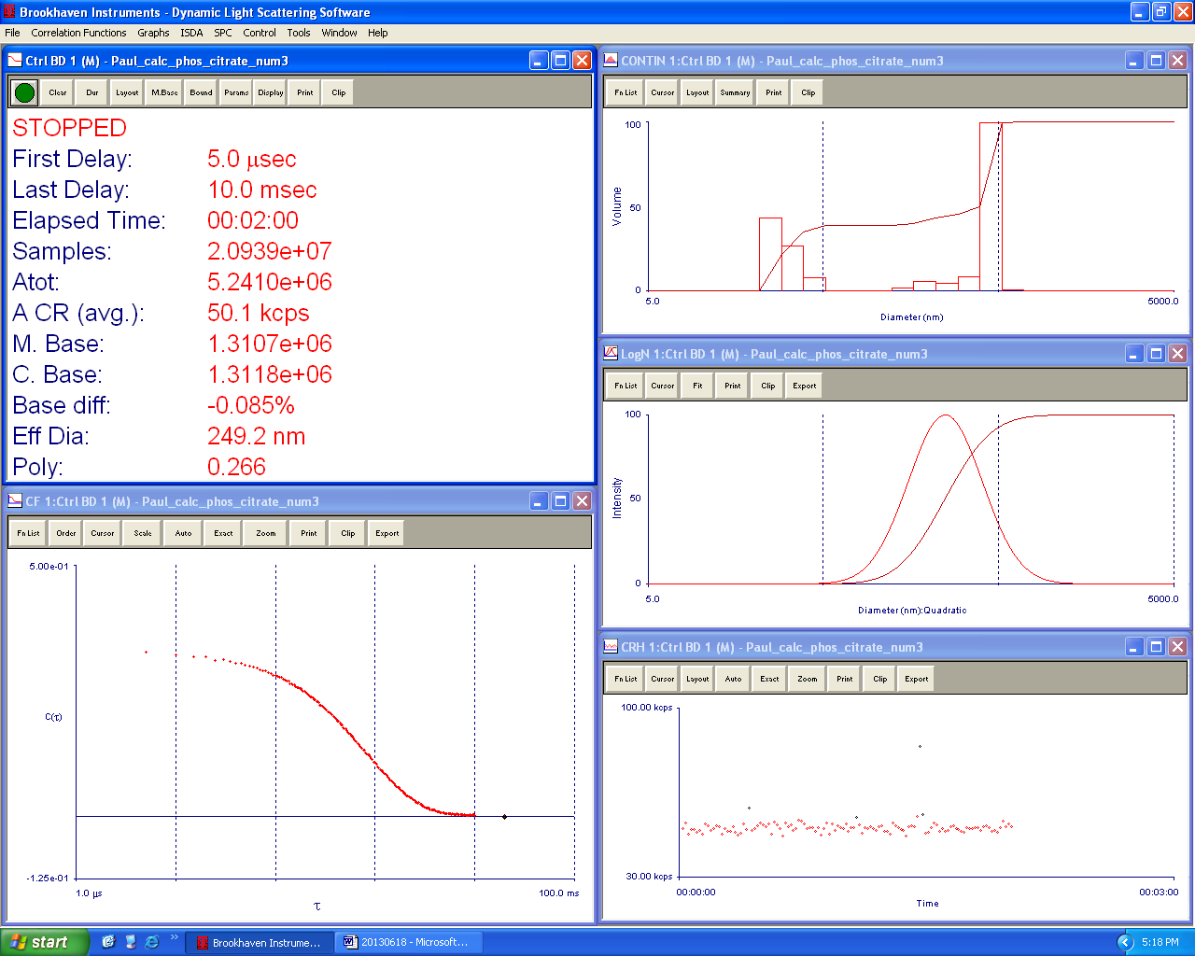
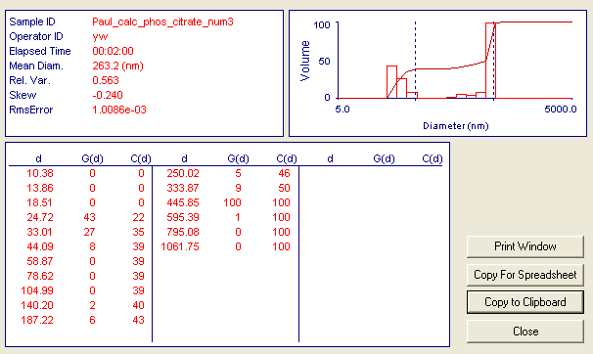
1.038167e+01, 0.000000e+00, 0.000000e+00
1.386362e+01, 0.000000e+00, 0.000000e+00
1.851341e+01, 0.000000e+00, 0.000000e+00
2.472270e+01, 4.347743e+01, 2.167775e+01
3.301456e+01, 2.721266e+01, 3.524592e+01
4.408747e+01, 7.853999e+00, 3.916191e+01
5.887417e+01, 0.000000e+00, 3.916191e+01
7.862025e+01, 0.000000e+00, 3.916191e+01
1.049891e+02, 0.000000e+00, 3.916191e+01
1.402018e+02, 2.213212e+00, 4.026541e+01
1.872248e+02, 5.706767e+00, 4.311079e+01
2.500189e+02, 4.806969e+00, 4.550753e+01
3.338739e+02, 8.523989e+00, 4.975757e+01
4.458535e+02, 1.000000e+02, 9.961736e+01
5.953903e+02, 7.674343e-01, 1.000000e+02
7.950810e+02, 0.000000e+00, 1.000000e+02
1.061747e+03, 0.000000e+00, 1.000000e+02

2. citrate + origami? Might want to switch 1 and 2
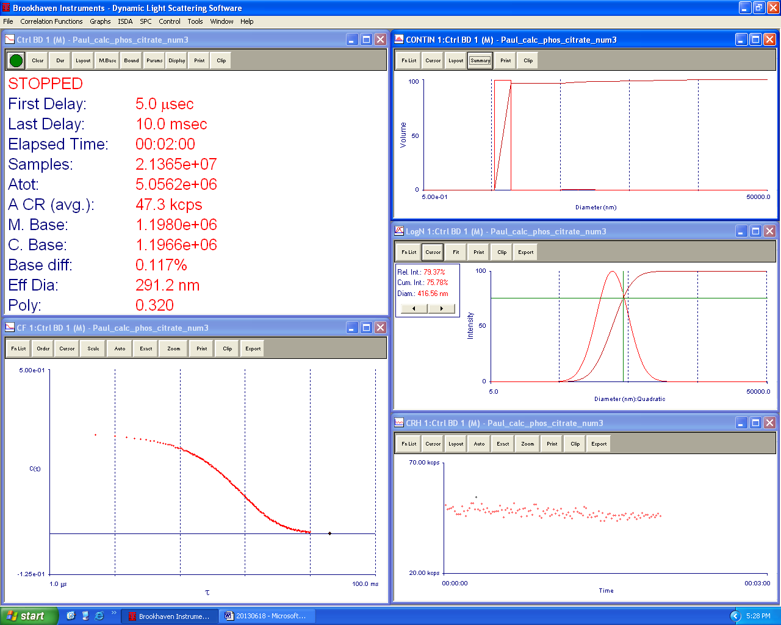
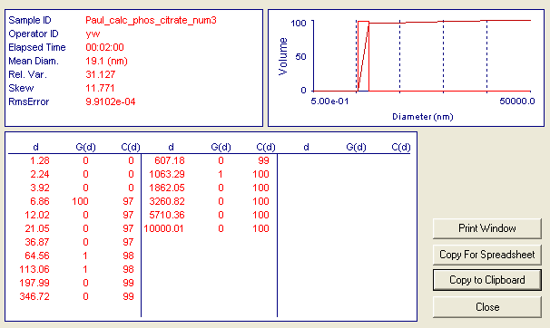
1.278244e+00, 0.000000e+00, 0.000000e+00
2.238466e+00, 0.000000e+00, 0.000000e+00
3.920009e+00, 0.000000e+00, 0.000000e+00
6.864735e+00, 1.000000e+02, 9.714330e+01
1.202155e+01, 0.000000e+00, 9.714330e+01
2.105218e+01, 0.000000e+00, 9.714330e+01
3.686665e+01, 0.000000e+00, 9.714330e+01
6.456102e+01, 7.108378e-01, 9.783383e+01
1.130595e+02, 6.394960e-01, 9.845506e+01
1.979902e+02, 2.113514e-01, 9.866037e+01
3.467211e+02, 3.992940e-01, 9.904826e+01
6.071793e+02, 3.505899e-01, 9.938884e+01
1.063295e+03, 5.089318e-01, 9.988323e+01
1.862046e+03, 1.185922e-01, 9.999844e+01
3.260821e+03, 1.613591e-03, 1.000000e+02
5.710361e+03, 0.000000e+00, 1.000000e+02
1.000001e+04, 0.000000e+00, 1.000000e+02

I ran it again with these results…
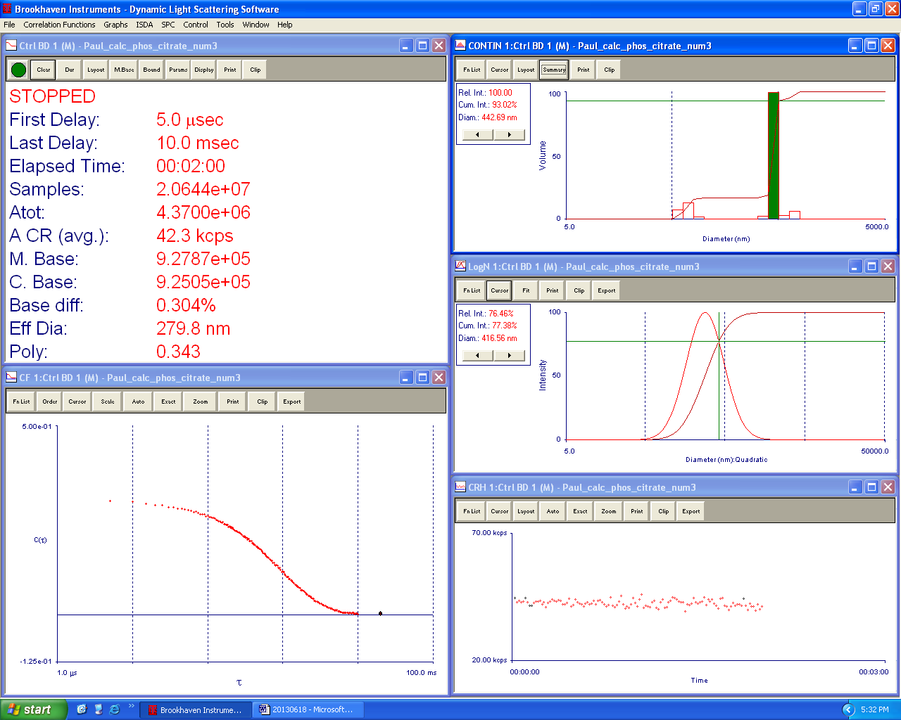
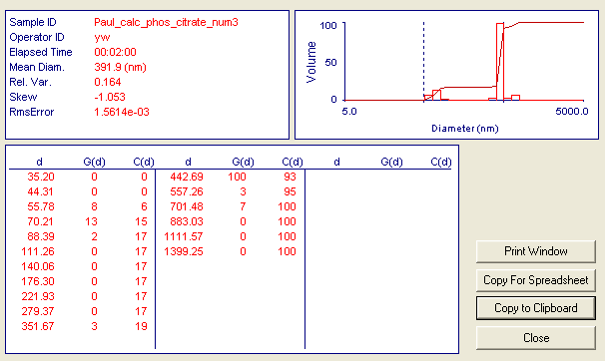
3.519989e+01, 0.000000e+00, 0.000000e+00
4.430992e+01, 0.000000e+00, 0.000000e+00
5.577770e+01, 7.647481e+00, 5.654844e+00
7.021343e+01, 1.328626e+01, 1.547922e+01
8.838525e+01, 2.108448e+00, 1.703829e+01
1.112601e+02, 0.000000e+00, 1.703829e+01
1.400551e+02, 0.000000e+00, 1.703829e+01
1.763026e+02, 0.000000e+00, 1.703829e+01
2.219311e+02, 0.000000e+00, 1.703829e+01
2.793688e+02, 0.000000e+00, 1.703829e+01
3.516718e+02, 2.760604e+00, 1.907958e+01
4.426873e+02, 1.000000e+02, 9.302346e+01
5.572585e+02, 2.807461e+00, 9.509941e+01
7.014817e+02, 6.627437e+00, 1.000000e+02
8.830310e+02, 0.000000e+00, 1.000000e+02
1.111567e+03, 0.000000e+00, 1.000000e+02
1.399250e+03, 0.000000e+00, 1.000000e+02

and another run after…
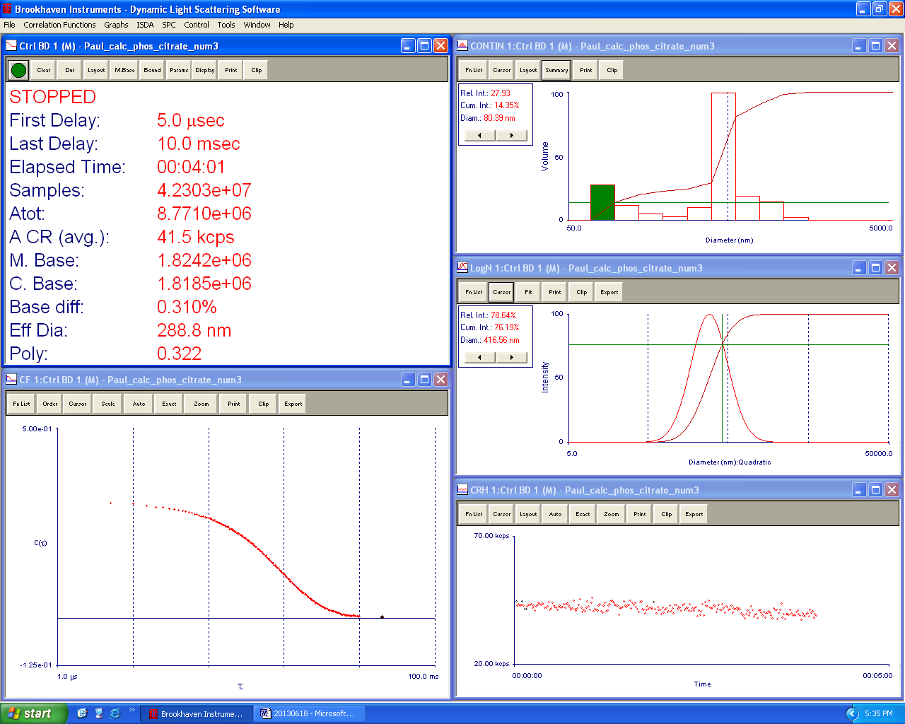
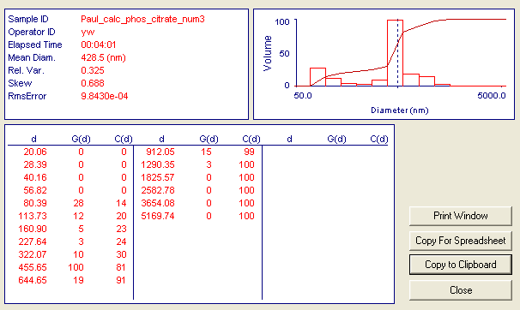
2.006423e+01, 0.000000e+00, 0.000000e+00
2.838657e+01, 0.000000e+00, 0.000000e+00
4.016088e+01, 0.000000e+00, 0.000000e+00
5.681901e+01, 0.000000e+00, 0.000000e+00
8.038668e+01, 2.792893e+01, 1.434810e+01
1.137299e+02, 1.171469e+01, 2.036635e+01
1.609033e+02, 5.019945e+00, 2.294528e+01
2.276435e+02, 2.963284e+00, 2.446762e+01
3.220666e+02, 1.013694e+01, 2.967533e+01
4.556549e+02, 1.000000e+02, 8.104892e+01
6.446537e+02, 1.934315e+01, 9.098619e+01
9.120463e+02, 1.480438e+01, 9.859173e+01
1.290349e+03, 2.741230e+00, 1.000000e+02
1.825567e+03, 0.000000e+00, 1.000000e+02
2.582784e+03, 0.000000e+00, 1.000000e+02
3.654083e+03, 0.000000e+00, 1.000000e+02
5.169742e+03, 0.000000e+00, 1.000000e+02

3. No Citrate, No DNA origami

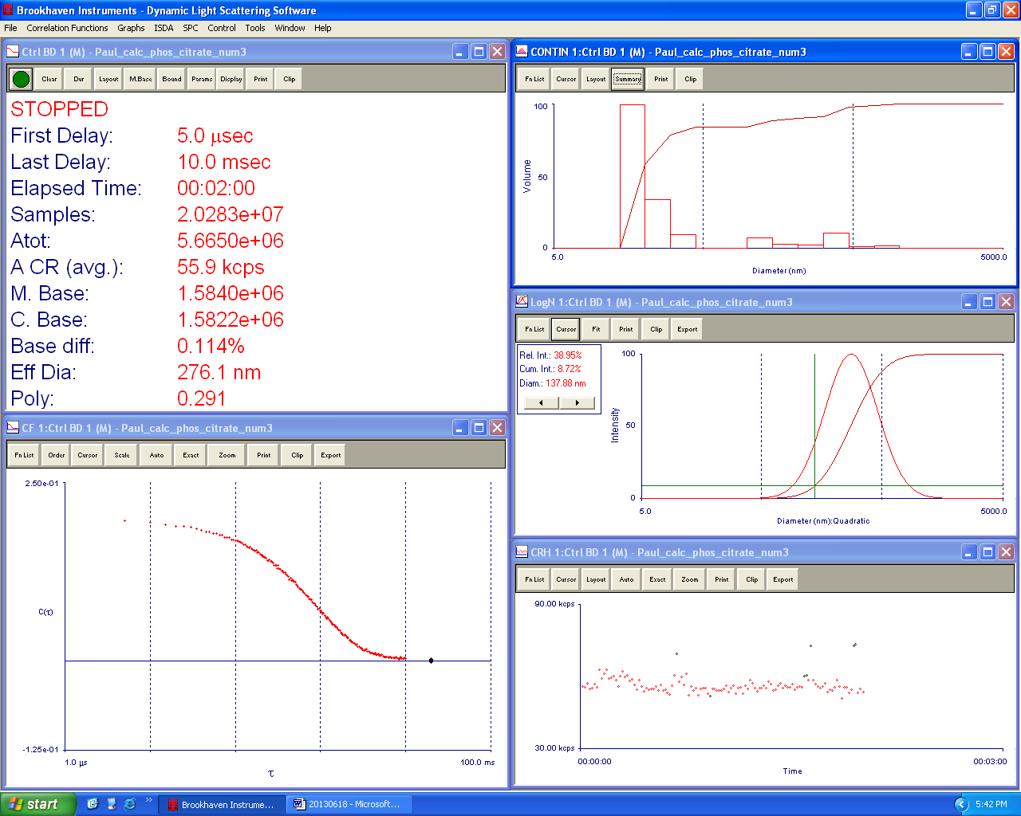
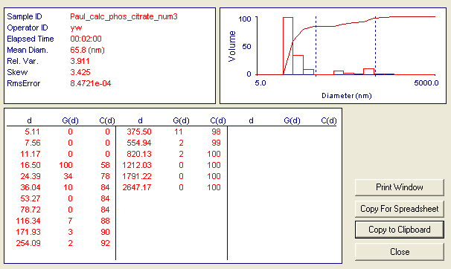
5.112592e+00, 0.000000e+00, 0.000000e+00
7.555704e+00, 0.000000e+00, 0.000000e+00
1.116629e+01, 0.000000e+00, 0.000000e+00
1.650223e+01, 1.000000e+02, 5.844839e+01
2.438801e+01, 3.426040e+01, 7.847305e+01
3.604210e+01, 9.778283e+00, 8.418830e+01
5.326524e+01, 0.000000e+00, 8.418830e+01
7.871867e+01, 0.000000e+00, 8.418830e+01
1.163353e+02, 7.273558e+00, 8.843958e+01
1.719275e+02, 3.231114e+00, 9.032811e+01
2.540851e+02, 2.364190e+00, 9.170994e+01
3.755026e+02, 1.075089e+01, 9.799367e+01
5.549409e+02, 1.618742e+00, 9.893980e+01
8.201259e+02, 1.813897e+00, 1.000000e+02
1.212033e+03, 0.000000e+00, 1.000000e+02
1.791217e+03, 0.000000e+00, 1.000000e+02
2.647170e+03, 0.000000e+00, 1.000000e+02

4. With origami, no citrate
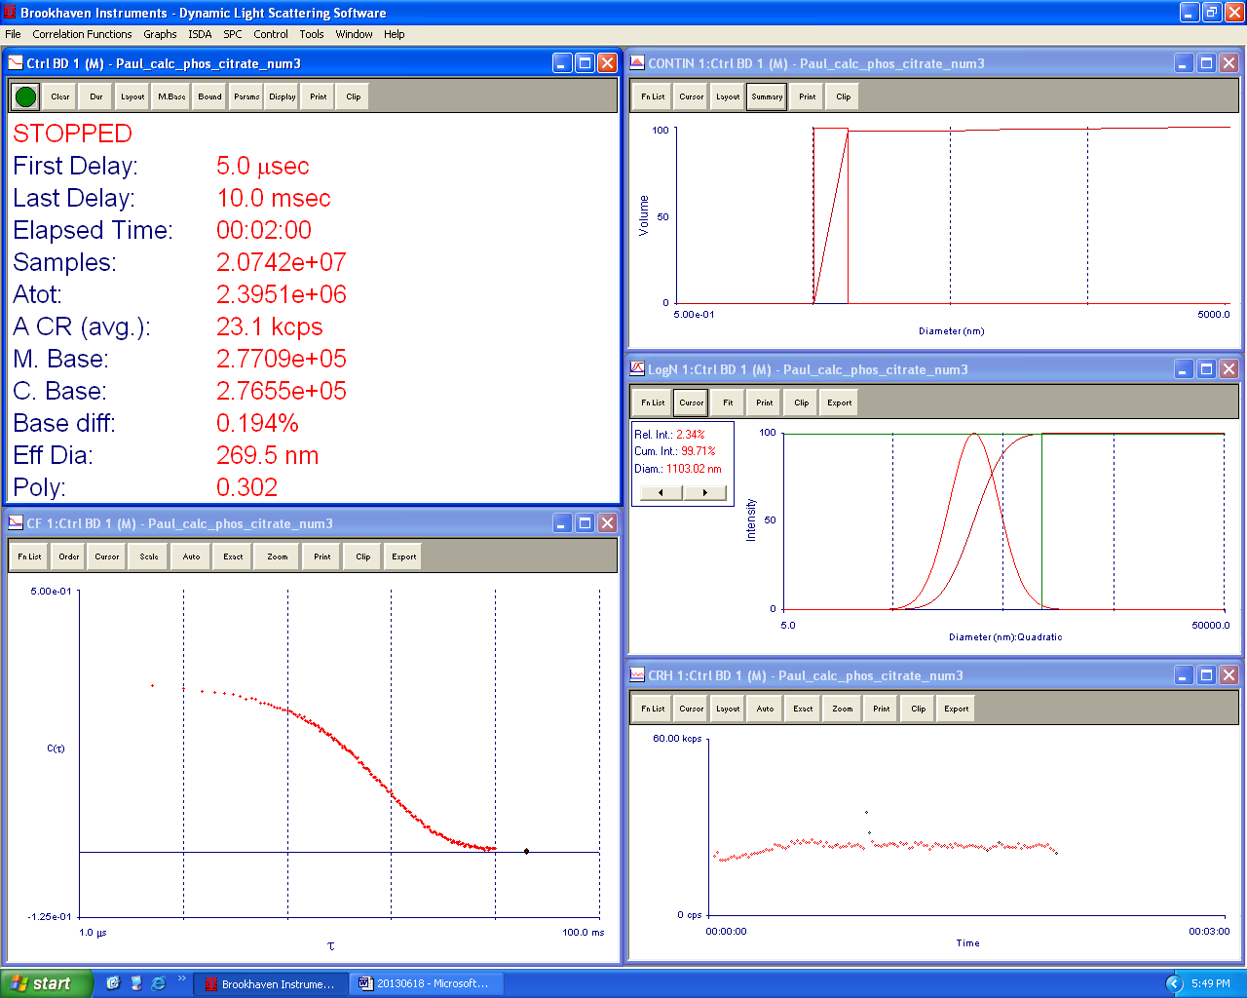

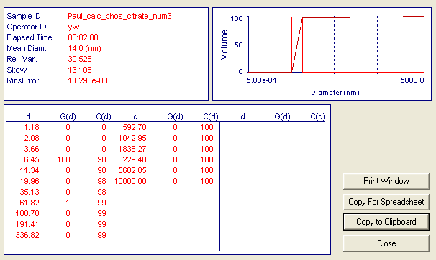
1.183210e+00, 0.000000e+00, 0.000000e+00
2.082070e+00, 0.000000e+00, 0.000000e+00
3.663777e+00, 0.000000e+00, 0.000000e+00
6.447074e+00, 1.000000e+02, 9.800027e+01
1.134479e+01, 0.000000e+00, 9.800027e+01
1.996319e+01, 0.000000e+00, 9.800027e+01
3.512883e+01, 0.000000e+00, 9.800027e+01
6.181548e+01, 5.102171e-01, 9.850028e+01
1.087755e+02, 4.925686e-01, 9.898300e+01
1.914100e+02, 1.538506e-01, 9.913378e+01
3.368202e+02, 2.363655e-01, 9.936542e+01
5.926957e+02, 2.285000e-01, 9.958935e+01
1.042955e+03, 3.969487e-01, 9.997836e+01
1.835266e+03, 2.207621e-02, 1.000000e+02
3.229481e+03, 0.000000e+00, 1.000000e+02
5.682853e+03, 0.000000e+00, 1.000000e+02
1.000000e+04, 0.000000e+00, 1.000000e+02

5. rediluted the origami+citrate, due to possible mislabeling. The 10:1 dilution of citrate was not by its respective stock bottle, but by the citrate + origami. The 10:1 dilution of dna and origami was beside the citrate stock.
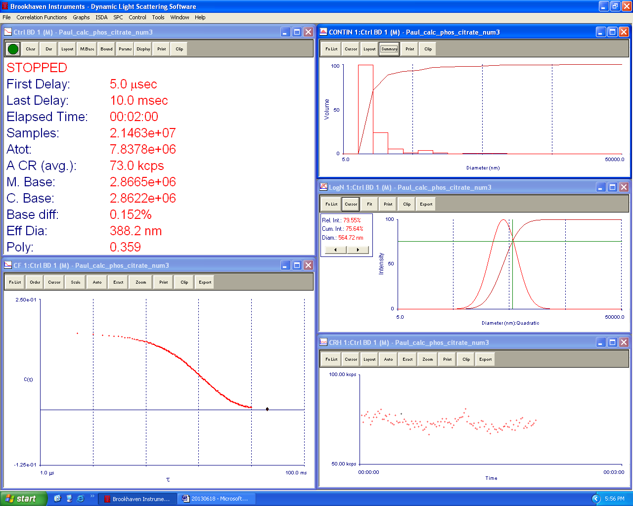
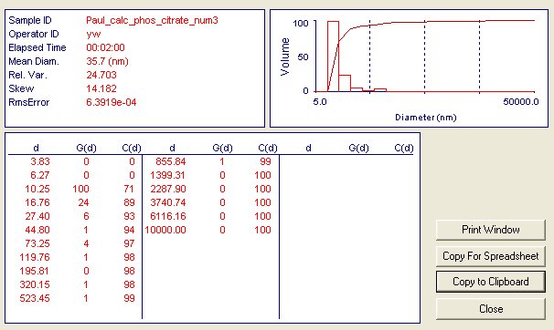
3.834074e+00, 0.000000e+00, 0.000000e+00
6.268761e+00, 0.000000e+00, 0.000000e+00
1.024951e+01, 1.000000e+02, 7.135813e+01
1.675808e+01, 2.416743e+01, 8.860356e+01
2.739967e+01, 5.867738e+00, 9.279067e+01
4.479882e+01, 1.447257e+00, 9.382340e+01
7.324667e+01, 4.017606e+00, 9.669029e+01
1.197593e+02, 1.142640e+00, 9.750566e+01
1.958079e+02, 4.426477e-01, 9.782152e+01
3.201485e+02, 6.139452e-01, 9.825962e+01
5.234470e+02, 9.226909e-01, 9.891803e+01
8.558427e+02, 7.831269e-01, 9.947686e+01
1.399314e+03, 4.174586e-01, 9.977475e+01
2.287896e+03, 2.103670e-01, 9.992487e+01
3.740741e+03, 9.520642e-02, 9.999280e+01
6.116160e+03, 1.008964e-02, 1.000000e+02
1.000000e+04, 0.000000e+00, 1.000000e+02

6. Rediluted the citrate stock tube. For same reason as above
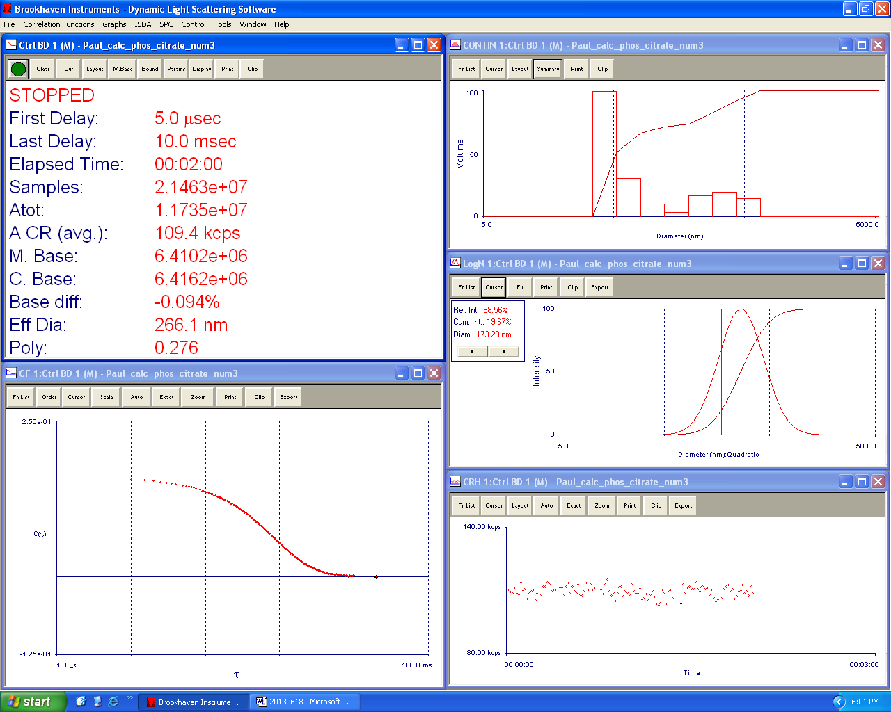
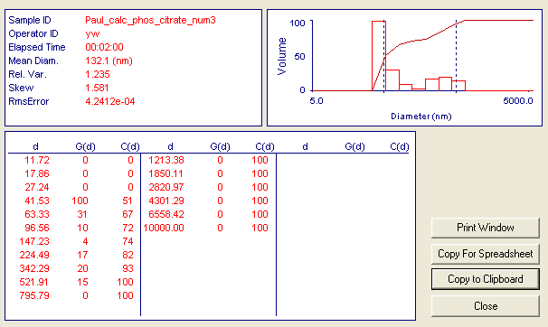
1.171628e+01, 0.000000e+00, 0.000000e+00
1.786448e+01, 0.000000e+00, 0.000000e+00
2.723900e+01, 0.000000e+00, 0.000000e+00
4.153285e+01, 1.000000e+02, 5.088681e+01
6.332751e+01, 3.091996e+01, 6.662099e+01
9.655906e+01, 1.014129e+01, 7.178157e+01
1.472291e+02, 3.779401e+00, 7.370479e+01
2.244886e+02, 1.707909e+01, 8.239579e+01
3.422906e+02, 1.995087e+01, 9.254815e+01
5.219099e+02, 1.464397e+01, 1.000000e+02
7.957858e+02, 0.000000e+00, 1.000000e+02
1.213380e+03, 0.000000e+00, 1.000000e+02
1.850110e+03, 0.000000e+00, 1.000000e+02
2.820968e+03, 0.000000e+00, 1.000000e+02
4.301290e+03, 0.000000e+00, 1.000000e+02
6.558422e+03, 0.000000e+00, 1.000000e+02
1.000000e+04, 0.000000e+00, 1.000000e+02

7. 6/20 CPNP with smaller aqueous volume, no origami, sonicated for 30 minutes. This is the diluted one I think.
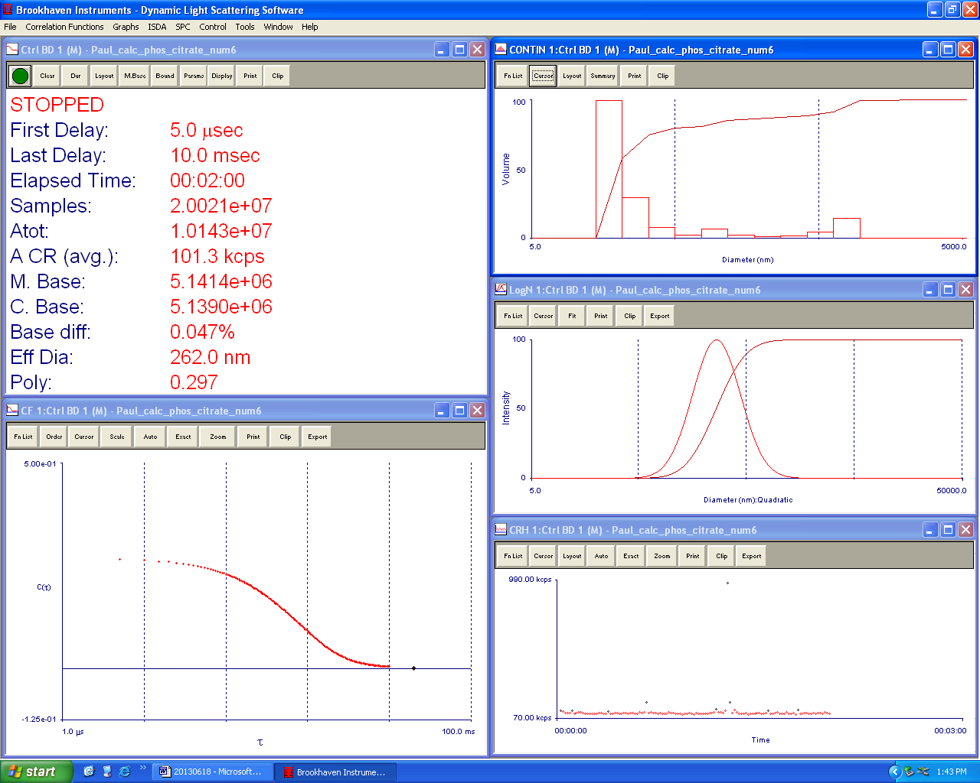
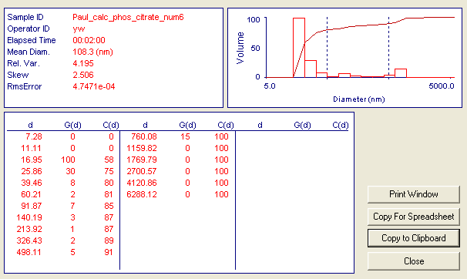
7.277778e+00, 0.000000e+00, 0.000000e+00
1.110533e+01, 0.000000e+00, 0.000000e+00
1.694588e+01, 1.000000e+02, 5.775872e+01
2.585810e+01, 2.983880e+01, 7.499323e+01
3.945747e+01, 8.103427e+00, 7.967366e+01
6.020906e+01, 2.250952e+00, 8.097378e+01
9.187440e+01, 7.212998e+00, 8.513992e+01
1.401933e+02, 2.626438e+00, 8.665691e+01
2.139241e+02, 1.337663e+00, 8.742953e+01
3.264317e+02, 2.206963e+00, 8.870425e+01
4.981096e+02, 4.650334e+00, 9.139022e+01
7.600770e+02, 1.458873e+01, 9.981648e+01
1.159819e+03, 2.808034e-01, 9.997867e+01
1.769794e+03, 3.692649e-02, 1.000000e+02
2.700570e+03, 0.000000e+00, 1.000000e+02
4.120862e+03, 0.000000e+00, 1.000000e+02
6.288118e+03, 0.000000e+00, 1.000000e+02

8. 6/20 CPNP with smaller aqueous volume, no origami, sonicated for 30 minutes. This is the non-diluted one I think.
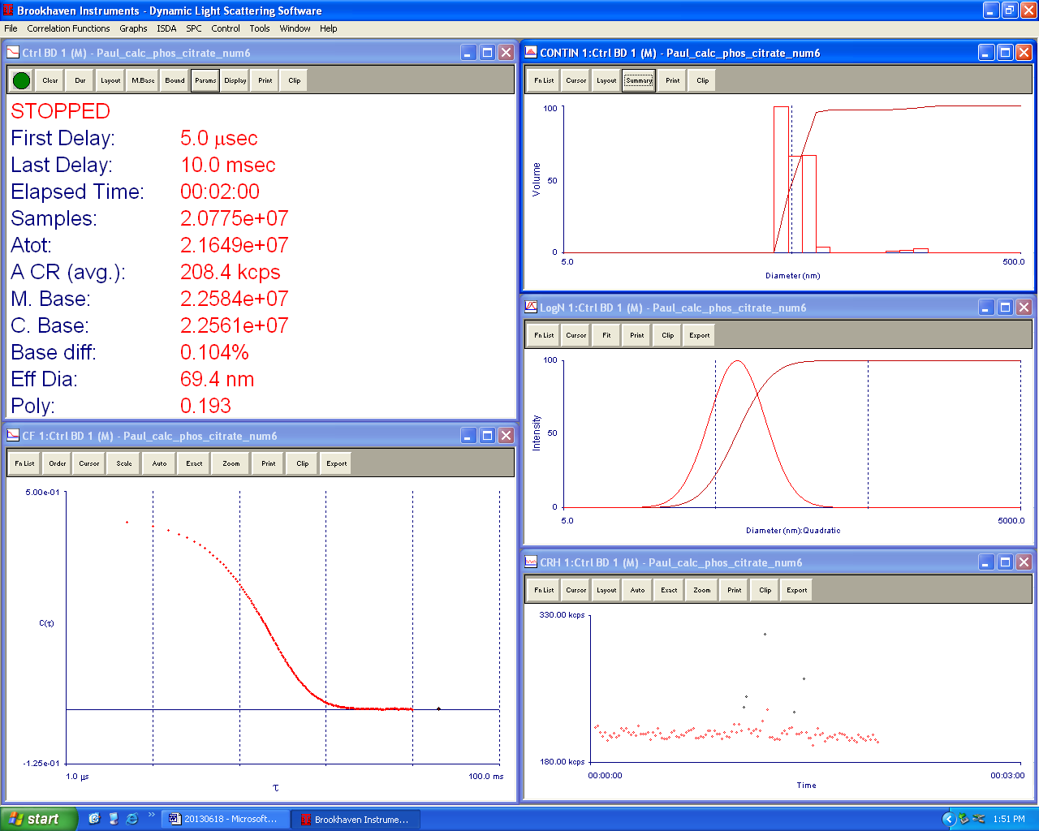
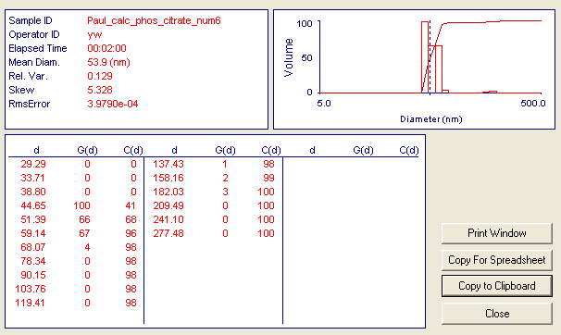
2.929178e+01, 0.000000e+00, 0.000000e+00
3.371135e+01, 0.000000e+00, 0.000000e+00
3.879775e+01, 0.000000e+00, 0.000000e+00
4.465159e+01, 1.000000e+02, 4.114670e+01
5.138866e+01, 6.629797e+01, 6.842612e+01
5.914223e+01, 6.670366e+01, 9.587247e+01
6.806567e+01, 3.956182e+00, 9.750031e+01
7.833547e+01, 0.000000e+00, 9.750031e+01
9.015480e+01, 0.000000e+00, 9.750031e+01
1.037574e+02, 0.000000e+00, 9.750031e+01
1.194125e+02, 0.000000e+00, 9.750031e+01
1.374295e+02, 1.218521e+00, 9.800169e+01
1.581650e+02, 1.804661e+00, 9.874425e+01
1.820291e+02, 2.869101e+00, 9.992478e+01
2.094938e+02, 1.828009e-01, 1.000000e+02
2.411024e+02, 0.000000e+00, 1.000000e+02
2.774801e+02, 0.000000e+00, 1.000000e+02

