**SEED Academy, Spring 2009**

**Synthetic Biology Module**

*Homework #5*

*Due March 21, 2009*

1. **Laboratory Project Overview**

Here, once again, is our lab schematic (adapted from MIT’s 20.109 DNA Engineering Module: <http://openwetware.org/wiki/20.109(F08):Module_1>). Please answer the question(s) that follow(s).

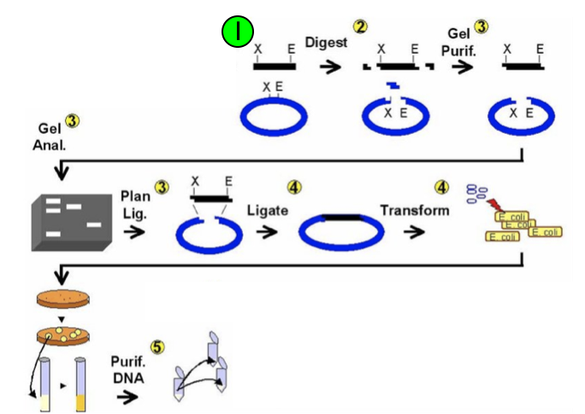

1. You will “Ligate” and “Transform” on Day 6. What are the “blue” and “black” pieces of DNA that you will be working with for these steps? Gives names and brief descriptions (e.g. J23100, constitutive promoter…)
2. **DNA Concentration Calculation from Absorbance Data**

The concentration of DNA is calculated from the following equation:



Where [DNA] is the concentration of DNA in mg/mL, A260 is the absorbance of the sample at 260 nm, A320 is the absorbance of the sample at 320 nm, and Ec is the extinction coefficient of DNA (20 mL/mg). The purity of DNA in the sample is determined from the ratios:

 and 

Target values for R1 are 1.8-2.0. If R1 is too low, there is likely contamination from protein. R2 indicates contamination from carbohydrates and aromatic compounds, with a high purity sample being under 0.5.

Complete the following table (using your own data in the first two rows).

|  |  |  |  |  |  |  |  |  |
| --- | --- | --- | --- | --- | --- | --- | --- | --- |
| **Sample** | **A230** | **A260** | **A280** | **A320** | **[DNA]**  **(ng/μL)** | **R1** | **R2** | **Purity/Contaminants/ Problems** |
| **1** |  |  |  |  |  |  |  |  |
| **2** |  |  |  |  |  |  |  |  |
| **3** | 0.05 | 0.2 | 0.1 | 0.15 |  |  |  |  |
| **4** | 0.8 | 1.7 | 0.9 | 0.2 |  |  |  |  |

1. **Back to your Final Project**

Come in prepared to discuss your ideas with your classmates, TA and instructors! They certainly do not need to be “perfect” ideas at this very moment, but, considering the work you have done so far on them including beginning to gather real world information about organisms and biological interactions/systems interfaces, you should have some idea of the actual biology behind your project.

As always, please feel free to send us questions.